 | Materials |  |  | 
 | Year Group: 5 | Subject Focus: Science | Term: Autumn 1
Key facts  - Materials can be grouped on the basis of their properties and through tests analysing their hardness, permeability, flexibility, solubility, transparency, conductivity (electrical and thermal) and response to magnets.  - Some materials will dissolve in liquid to form a solution.  - You can recover a substance from a solution by evaporation.  - Some materials will not dissolve.  - A material that dissolves is called a solute, the liquid it is dissolved in is a solvent. The resulting mixture is a solution.  - A solution is saturated when no more solid will dissolve in it.  - Mixtures can be separated through filtering, sieving and evaporating.  - Materials have different purposes depending on their properties, for example metal is a good thermal conductor, wood a useful thermal insulator; plastic is light, cheap and non-permeable.  - Dissolving, mixing and changes of state such as evaporation, melting and freezing are reversible changes (physical changes).  - Chemical changes can be created by burning, mixing or heating. |  | Changes of materials  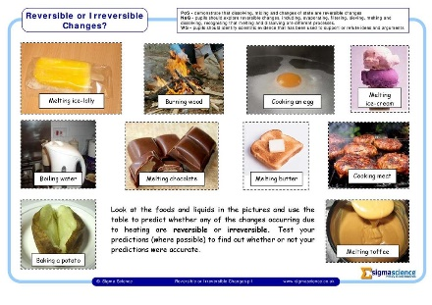  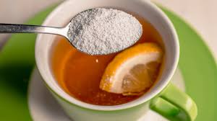 | Key words:
  conductor | a substance or material that allows electricity and heat to flow through it
  dissolve | the process where a soluble substance is added to a liquid to form a solution
  filter | the process of separating particles from a liquid
  insoluble | a solid that will not dissolve in a liquid even after mixing (sand and water)
  irreversible | a change that cannot be changed back to its original state
  mixture | a combination of two or more substances/materials
  reversible | a change that can be changed to its original state
  soluble | a substance that dissolves in a liquid is soluble
  solution | a mixture of two or more substances, where one is dissolved
  thermal insulator | materials that do not allow heat and electricity to flow through easily/at all
Did you Know?
Baking involves chemical changes that are irreversible.
Chemical changes result in the formation of new materials, and this kind of change is not usually reversible, including changes associated with burning and the action of acid on bicarbonate of soda or in cooking: pancakes, making omelettes, cooking pasta or baking bread.

 |  | Exciting books/ web links:  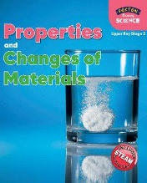  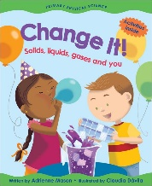   | Parents as partners:  Help your child to investigate irreversible changes through baking buns. Is it possible to separate the raw eggs from the cooked buns?  How many different types of materials can you identify around your home?  Have a go at melting chocolate, can you reverse this change and cool it down again?

