 | Art: Drawing
 | Year Group: 3 | Subject Focus: Art | Term: Autumn 1
Skills:  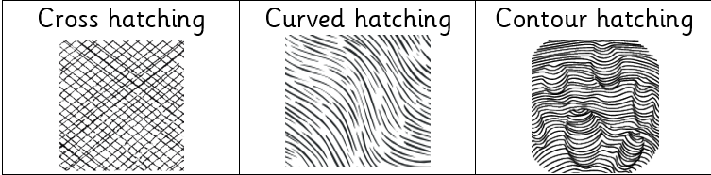  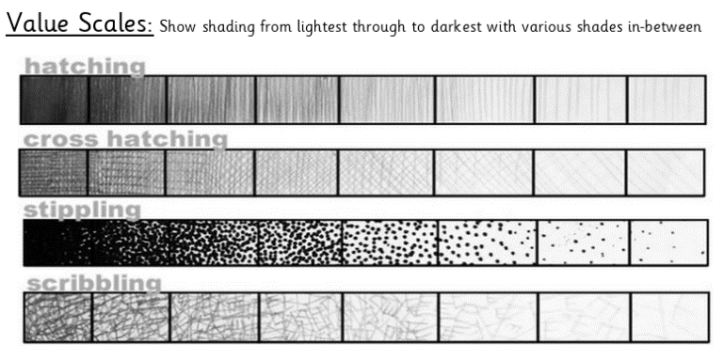  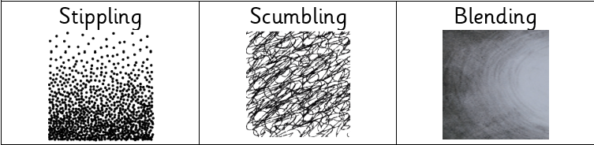  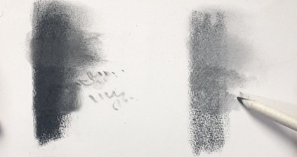  Blending |  | 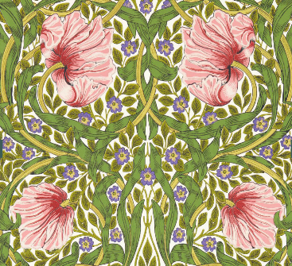  Famous Artwork:  William Morris- Sap Green Pimpernel  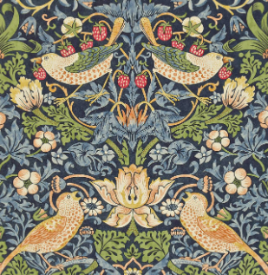  William Morris- Strawberry Thief  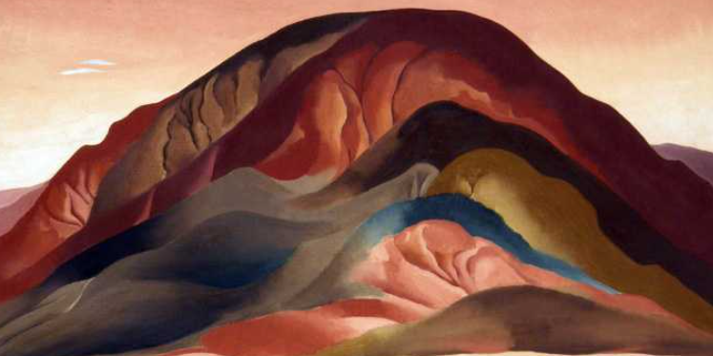  Georgia O'Keeffe, Rust Red Hills | Key words:  About the artists:  WILLIAM MORRIS  - He was born 24th March 1834 and died 3rd October 1896.  - He was an English Textile Designer, Poet, Artist and Writer.  - No single individual in Britain has had such a lasting impact on the history of British design.  GEORGIA O’KEEFE  - She was born in 1887 and was an American artist who painted nature in a way that showed how it made her feel.  - She is best known for her paintings of flowers and desert landscapes.  - She was the first female painter to gain respect in New York's art world in the 1920s.
  Cross hatching | Adding straight, parallel lines, which face in a different direction, over hatching.
  Contour hatching | Similar to regular hatching, but the lines will follow the curves or outline of the subject matter
  Curve Hatching | Small lines which are not straight.
  Contrast | To draw attention to the piece of art work.
  Blending | Rubbing or smudging to create a gradual transition to soften lines.
  Tone / Tonal | Providing a range of light to dark by shading with pencil.
  Gradient | Gradually transitioning from one hue to another, or from one shade to another, or one texture to another.
  Pressure | The amount of force applied- this will determine the darkness of the piece.
  Scale | The size of one object in relation to the other.
  Tone | The quality of the colour.

