Year 3 Newsletter (Autumn 1)

Welcome to Year 3! I hope you had a lovely break and are ready for all of our wonderful learning this half term.
Our learning journey
Geography  This half term, children will develop geographical skills and fieldwork techniques while studying human geography in their local area, Cross Gates. They will explore the community’s features, follow maps and use Digimaps to identify landmarks, and learn to observe, record, and present information about their local environment.  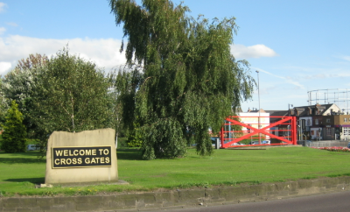 | Science  This half term, children will learn about different types of animals and their groups. They will explore the human skeleton and muscles, discovering how they help us move and protect organs. Children will also study the importance of a balanced diet and exercise and take part in simple investigations to observe and record their findings.  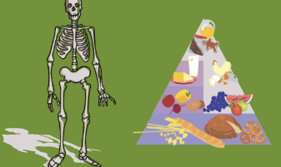 | Maths  This term in Maths, our learning will focus on Place Value. The children will use place value charts to work with numbers up to 100. This will include partitioning numbers, counting in 2s, 5s, and 10s up to 100, comparing and ordering numbers, and later moving on to addition and subtraction of 3-digit numbers across 100.  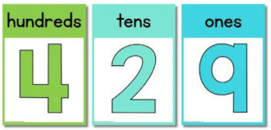 | English and Reading  This half term, our Year 3 class will be focusing on our class author Adrian Edmondson. In reading and writing, we will explore his famous book Tilly and the Time Machine. The children will write their own stories set in familiar settings, using a variety of sentence openers and ambitious vocabulary. Later, they will write with a purpose to inform by creating a non-chronological report all about Cross Gates  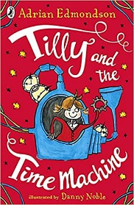

Other:  - PE days are on a Monday and a Tuesday. If your child wears earrings, please make sure that they are taken out or covered before school on these days. | Class routines:  - The children are expected to read at home every night. Reading records and books should be brought to school every day so that a member of staff can read with them in school. These reading books will be changed on a Friday if the reading record has been signed.  - Each Friday, the children will complete a spelling quiz. Spellings will be sent home of a Friday and should be practised at home.  - Pupils should continue to log onto TTRockstars to improve their times tables knowledge. This can be done through ‘Jamming’ focusing on our 2,3,4,5,8 and 10 times tables.

Finally, please remember to log onto the class page on the school website to keep up to date with our latest news: https://www.crossgatesprimary.co.uk/class-pages/ or by accessing the school twitter page.
Miss Croft

