 | Animals Including Humans |  |  | 
 | Year Group: 3 | Subject Focus: Science | Term: Autumn 1
Key facts  - Animals, including humans, need the right types and amount of nutrition. They need food to grow, be strong and stay healthy.  - The 5 food groups are: Fruit and veg, carbohydrates, fats, proteins and dairy.  - Humans should eat a balanced diet that is mainly made up of fruit and veg and carbohydrates, with some proteins and dairy and a small amount of foods containing lots of fat and/or sugar.  - Nutrients that pupils should learn about are: Protein, fibre, carbohydrates, fat, vitamins and minerals.  - Animals including humans need skeletons and muscles for support, protection and movement. |  | Our Learning Journey:  We Are Learning To…  - Identify that animal, including humans, need the right types and amount of nutrition, and that they cannot make their own food; they get nutrition from what they eat.  - Identify that humans and some other animals have skeletons and muscles for support, protection and movement.  Our five enquiry types:    Working Scientifically Skills:  In this unit we will be:    Asking Questions    Making Predictions    Observing    Interpreting and Communicating Results    Evaluating  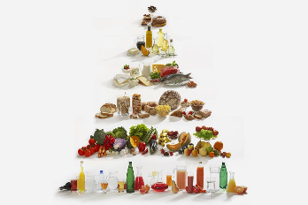 | Key words:
  nutrition | Providing foods for necessary health and growth.
  protein | Builds and maintains the tissues in your body- such as muscles! A form of protein is chicken.
  fat | A source of energy essential in our diets. It also acts as insulation to keep our bodies warm.
  fibre | Keeps the digestive system healthy.
  vitamins | The nutrients that we need in order to grow and stay healthy.
  minerals | An example of a mineral is calcium. This keeps are bones and teeth strong and healthy.
  skeleton | The bones of the body.
  bones | The pieces of hard tissue which makes up the skeleton.
  muscles | A band of tissue in the body which contract, producing movement.
  carbohydrates | One of the main nutrients in food. They are the body’s major source of energy.
Key people
Wilhelm Röntgen – German mechanical engineer who discovered X-rays.

Adelle Davis – American author and famous nutritionist in the early to mid-20th century.
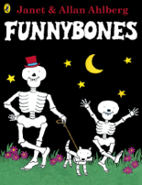
Exciting books/ web links:

- McDonald’s Nutrition Calculator – https://www.mcdonalds.com/gb/en-gb/good-to-know/nutrition-calculator.html
- Polar Explorer Resources – https://www.stem.org.uk/welcome-polar-explorer-programme

Parents as partners:
Could your child write a set of instructions (recipe) explaining how to make a healthy snack such as a salad or healthy pizza?

Explore with your child, do our parents need a different diet to ours? How about sportspeople, or people who live in different environments?

