 | Cross Gates Local Study
 | Year Group: 3 | Subject Focus: Geography | Term: Autumn 1
Key facts  - Maps use compass points to help people know which direction they are facing.  - Humans use land for different activities, we can look at land and tell what it is/has been used for.  - There is a difference between physical geography (the natural features of land) and human geography (how humans have affected land).  - To know the location of Cross Gates. Cross Gates is a suburb in the city of Leeds. Leeds is in the county of West Yorkshire, the country England and in the continent of Europe.  - When coal mines were opened nearby the village began to grow.  - With the arrival of the railway the village became a popular place for families to live and grew into a suburb. |  | Sketch Map  Title  • Labels/annotations  • Simple lines  • Enough detail to give a rough idea  • A ‘not to scale’ note  • A north arrow  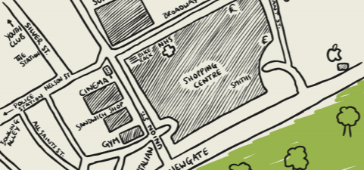  Physical Features Human Features  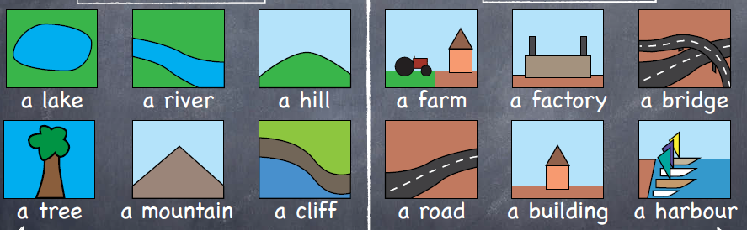 | Key words:
  compass | An instrument for showing direction using points (North, South, East, West).
  urban | A city or town.
  suburb | An area or community located just outside a city or town.
  rural | Countryside
  Ordnance  Survey | A type of map.
  human features | Things that are made or built by humans such as railways and farms.
  topographical | The arrangement of physical features of an area.
  landmark | A feature of the landscape or area that is easily recognised.
  valley | A low area of land between hills or mountains, typically with a river or stream flowing through it.
  physical features | Things that are part of the earth’s natural features such as mountains and rivers
Key people/ places
- Cross gates Shopping Centre
Originally named the Cross Gates Arndale Centre, the first indoor ‘American Style’ shopping mall in England and opened on 21st September 1967.
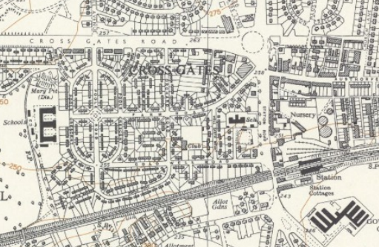
- Barnbow Factory A munitions factory in the First World War and Second World War
 |  | Exciting books/ web links:  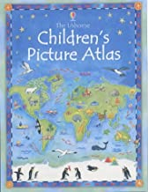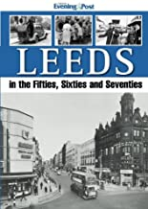 | Parents as partners:  - Explore different areas of Cross Gates comparing the different buildings and businesses in the area.  - Find out how many parks are in the areas.  - Draw a map of a favourite area or route.  - Make a collage or poster of favourite places in the area.

