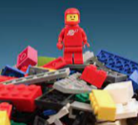 | Toys Then and Now |  |  | 
 | Year Group: 1 | Subject Focus: History | Term: Autumn 1
Key Questions  - How long have toys existed?  - What were toys made of during the Victorian age?  - What toys did Victorian children play with?  - What are modern toys made of?  - How are modern toys different?  Key facts  - Our local area has changed over time, and so have the lives of the people who live here.  - Some toys and games are thousands of years old.  - Dolls are one the earliest forms of toy to exist.  - Teddy bears were invented over 100 years ago.  - We can compare the differences between toys now and in the past by asking other grown-ups questions, reading books and using the internet to find out information. |  | In the past children played with different games and toys depending on whether they were a girl or boy/ rich or poor.  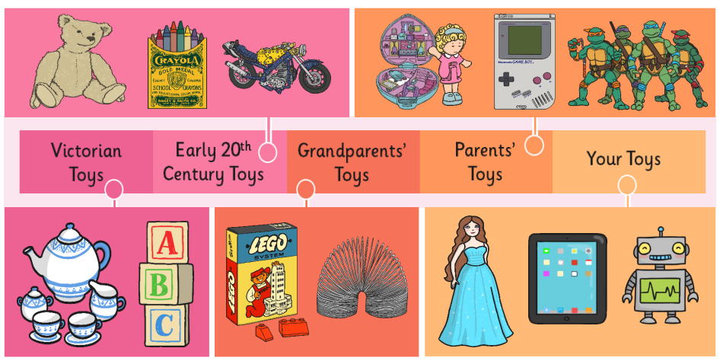  Key Themes.  This half term our theme will be society!  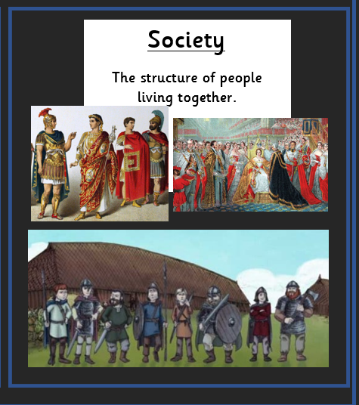 | Key words:
  decade | A period of ten years
  past | Time that has gone by and already happened
  present | Time that is occurring right now
  old | Something that has been around for lots of years
  modern | Something that exists in the present day
  compare | Looking at objects and saying what is the same or different
  Victorian | A time period where Queen Victoria ruled
  material | Something that an object is made from
  century | A period of 100 years
  factory | A building where things are made by machines
 |  | Exciting books/ web links:  - KS1 History. Changes within living memory: Toys - BBC Teach  - Old and New Toys Interactive Sorting Activity  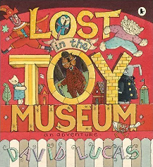  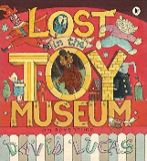  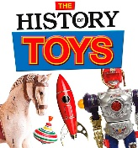 | Parents as partners:  - Look at old family photographs together and compare what looks the same and different to now.  - Discuss your toys and school life in the past, or ask older members of the family. What is the same? What is different?

