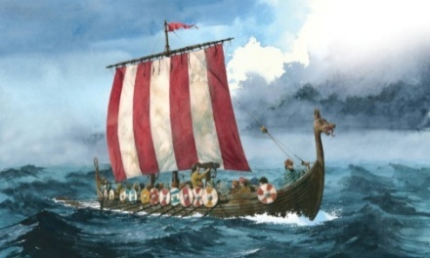
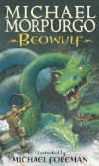

https://www.google.com/url?sa=i&url=https%3A%2F%2Fwww.etsy.com%2Fuk%2Flisting%2F1477679581%2Fsummer-png-transparent-non-transparent&psig=AOvVaw2fl3BkaGXQlJgCJKfQLgXZ&ust=1748794312520000&source=images&cd=vfe&opi=89978449&ved=0CBQQjRxqFwoTCKCritCMzo0DFQAAAAAdAAAAABAE
HOMEWORK - Please ensure that your child practises words from their spelling lists, and completes online learning tasks such as TTRockstars, purple-mash and mathsbot!
READING – Please ensure that your child reads as often as possible. Reading for pleasure is considered the single most important factor for a child's future success in education and life.
PE – We are excited to be starting swimming lessons this term, which will be on a Monday afternoon. Please ensure your child comes to school with their swimming costume/shorts and brings a towel. We will also have PE this term on a Wednesday. Please ensure your child comes in their PE kit with appropriate trainers on this day. All long hair must be tied up and jewellery must be removed during PE.
Science
Our science topic this term is ‘Properties of Materials’. We will recap solids, liquids and gases, and learn how to compare and group together materials based on evidence from observations and fair tests. We will also experiment with reversible and irreversible changes!

Dear Parents and Carers,

Welcome to the start of a brand-new school year, I hope you have had a restful summer holiday, and your child is looking forward to starting Year 5!

Year Five
Newsletter
September 2025

History: In history this term, our topic is the Anglo-Saxons! We will be learning all about the Anglo-Saxon’s invasion of Britain and what life was like as an Anglo-Saxon.
PSHE: We will be learning about physical health and well-being.
Art: We will be focusing on the skill of drawing. Drawing self-portraits and looking at pieces inspired by Banksy and Keith Haring.
Music: We will be exploring different types of music such as funk and house!

French: We will be learning phonetics, and recapping basic conversational phrases.
RE: We will be learning about Judaism and the many Jewish festivals.
Computing: Online safety.

Maths
In Maths, we will be focusing on place value, recognising numbers up to 1,000,000! We will learn about roman numerals, and how to partition numbers in a variety of different ways. In arithmetic, we will focus on key skills and complete weekly tests to consolidate our knowledge!

In English, and Reading

This term, we will be reading Beowulf by Michael Morpurgo. We will be delving into the world of the evil monster, Grendel, and the hero Beowulf! We will be writing a newspaper report about the events in the story, as well as exploring Anglo-Saxon Kenning poems!

