 | Art: Drawing
 | Year Group: 1 | Subject Focus: Art | Term: Autumn 1
Skills:  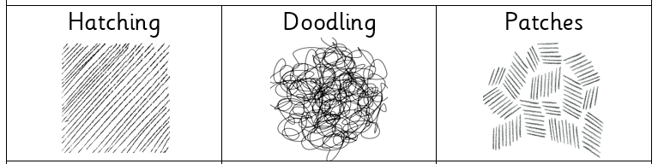  Different types of lines  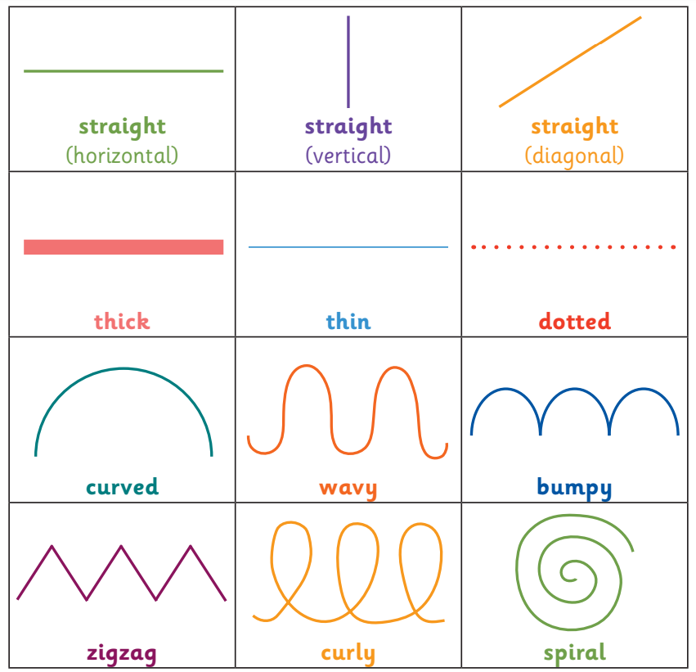 |  | Famous Artwork:  Bridget Riley: Movement in squares  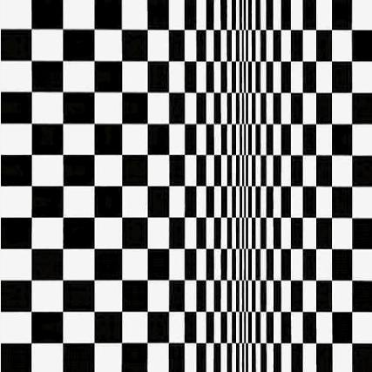  Bridget Riley: Nataraja    Zaria Forman: Greenland No.62   | Key words:  About the artists:  Bridget Riley  - Born in London in 1931.  - Her artwork uses optical illusions, wavy lines and loved black and white.  - Her art seems to move on the page!  Zaria Forman  - Born in the USA in 1982.  - Travels the world and looks at different climates for her artwork
  blending | Rubbing or smudging to create a gradual transition to soften lines.
  doodling | Freely draw patterns and images.
  form | The techniques used in a piece of artwork.
  hatching | A style of shading with parallel lines
  light | Brighter and bolder.
  patches | Small sections of hatching.
  shade | Dulling down a colour with black to make it darker.
  shadow | Darker areas blocked by light.
  sketch | Drawing an outline quickly with many small strokes.
  texture | The surface of a piece of art.

