 | Art: Drawing
 | Year Group: 5 | Subject Focus: Art | Term: Autumn 1
Skills:  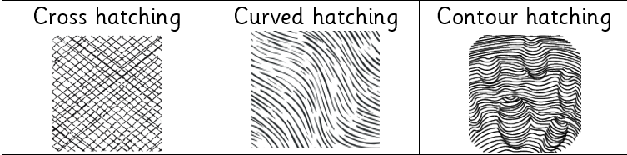  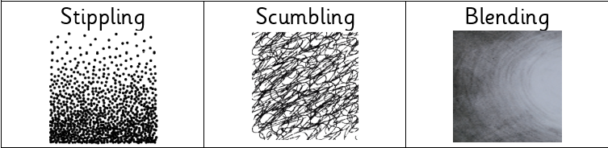  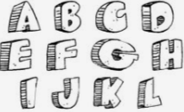  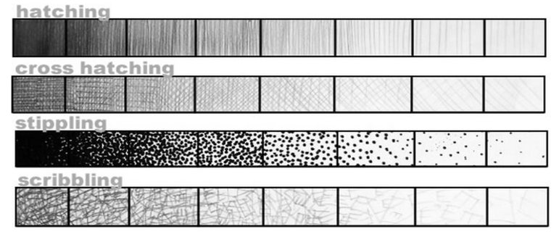 |  | Famous Artwork:  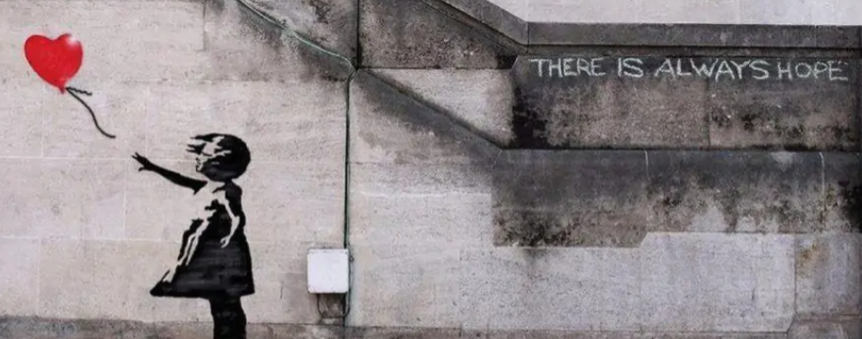  Banksy: There is always hope  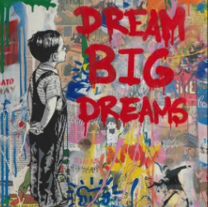  Banksy: Dream big dreams  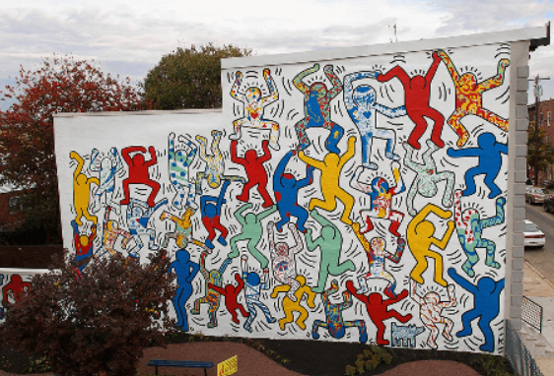  Haring: We the youth | Key words:  About the artists:  Banksy  - A street artist from England.  - His real name and identify is unknown.  - He uses art to make a statement and show how he feels about something.  - A piece of famous artwork – named Love is in the Bin – was sold at an auction for £1.4million. As it sold, it activated a shredder and was destroyed.  Keith Haring  - His work is known as pop art or street art.  - His art expresses his feelings and what he cares about.  - His art often showed people and animals.
  cross hatching | adding straight, parallel lines, which face in a different direction, over hatching
  curved hatching | curved parallel lines
  contour hatching | similar to regular hatching, but the lines will follow the curves or outline of the subject matter
  stippling | made up of dots, specks or small dashes
  scumbling | made up of small scribbles, loops, zig-zags or curves
  blending | rubbing or smudging to create a gradual transition to soften lines
  tone / tonal | providing a range of light to dark by shading with pencil
  gradient | gradually transitioning from one shade to another or one texture to another
  chiaroscuro | dramatic light and shade to create a three-dimensional effect
  composition | how the artwork is arranged or organised

