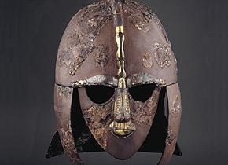 | Anglo-Saxons |  |  | 
 | Year Group: 5 | Subject Focus: History | Term: Autumn 1
Key facts:  - The Anglo-Saxons were made up of three tribes: the Angles, Saxons and Jutes, who invaded Britain after the Roman army left Britain in 410 AD.  - The name ‘Angles’ eventually became ‘English’ and their land, ‘Angle-land’, became ‘England’.  - They came to Britain from across the North Sea in the middle of the 5th Century.  - By AD 660, Britain was split into 7 kingdoms: Northumbria, Mercia, East Anglia, Essex, Wessex, Sussex and Kent.  - The impact of the Anglo-Saxons on life in Britain can still be seen today, for example in our place names and language.  - The Anglo-Saxon period ended when the Normans conquered Britain in 1066.  Key themes:  The key historical themes we will cover in our unit on the Anglo-Saxons are society, invasion and monarchy. |  | 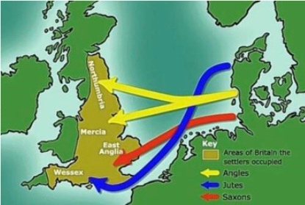  Timeline  AD  410 Roman army left Britain.  449  - 450 Angles and Saxons invade Britain.  516 Battle of Mount Badon  597 St. Augustine came to England and introduced people to Christianity  600 England was successfully split up into different  kingdoms.  633 The first monasteries were built.  789 First Viking raid recorded in Dorset. | Key words:
  Angles | tribes from Germany who settled in England
  Jutes | a tribe from northern Denmark who settled in Britain
  Saxons | tribes from Germany and the Netherlands who settled in Britain
  Scots | people from Scotland who were fierce and powerful fighters
  conquered | to take control of a place by force
  invade | to enter a place using force
  monk | a man who devotes his life to religion
  pagan | people who didn’t believe in just one god, but many gods and goddesses
  thane | an important Anglo-Saxon person
  wergild | a fine for stealing or killing
Did you know?
One of the most important archaeological sites from the
Anglo-Saxon era is the burial site at Sutton-Hoo in East Anglia, where a whole ship was used as a grave!
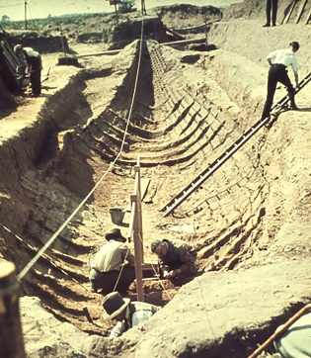
An Anglo-Saxon king was buried inside the ship along with some of his possessions, such as his helmet, sword, gold and jewellery. Lots of our knowledge about the Anglo-Saxons comes from the first-hand evidence found at this site.

 |  | Exciting books/ web links:  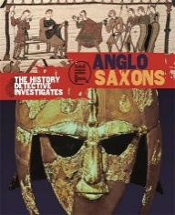  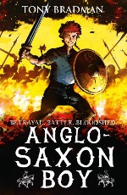  https://www.bbc.co.uk/bitesize/topics/zxsbcdm  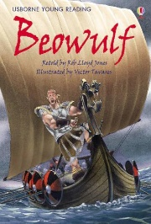 | Parents as partners:  - Encourage your child to create some amazing fact cards about the Anglo Saxons.  - Together, make an Anglo-Saxon house using recycled materials.  - Create a word search or crossword about the Anglo Saxons  - Visit some of the websites and talk about what you discover. Could you share your learning in a poster?

