 | Animals Including Humans |  |  | 
 | Year Group: 3 | Subject Focus: Science | Term: Autumn 1
Key facts  - Animals, including humans, need the right types and amount of nutrition. They need food to grow, be strong and stay healthy.  - The five food groups are: fruit and veg, carbohydrates, fats, proteins and dairy.  - Humans should eat a balanced diet that is mainly made up of fruit and veg and carbohydrates, with some proteins and dairy and a small amount of foods containing lots of fat and/or sugar.  - Nutrients that pupils should learn about are: protein, fibre, carbohydrates, fat, vitamins and minerals.  - Animals including humans need skeletons and muscles for support, protection and movement. |  | Our Learning Journey:  We Are Learning To…  - Identify that animal, including humans, need the right types and amount of nutrition, and that they cannot make their own food; they get nutrition from what they eat.  - Identify that humans and some other animals have skeletons and muscles for support, protection and movement.  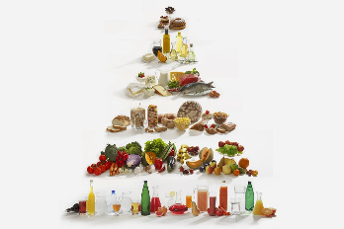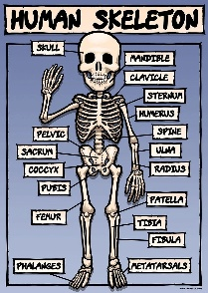  Science Skills:  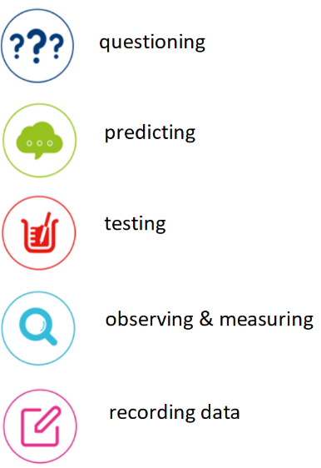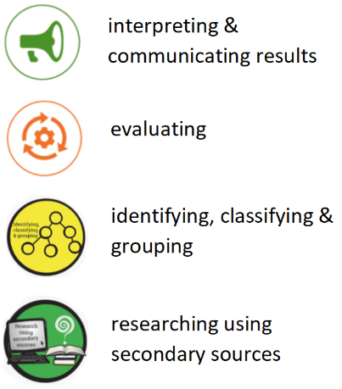 | Key words:
  nutrients | Substances found in food that carry out certain jobs in the body
  protein | Builds and maintains the tissues in your body- such as muscles! A form of protein is chicken.
  healthy | Having a strong body that functions properly through a balanced diet, regular exercise and good hygiene.
  unhealthy | A body condition, food choice or lifestyle that prevents a living thing from working properly or increases the risk of sickness and disease.
  vertebrate | An animal that has a backbone or spine inside its body.
  invertebrate | An animal that does not have a backbone or spine.
  skeleton | The bones of the body.
  bones | The pieces of hard tissue which makes up the skeleton.
  muscles | A band of tissue in the body which contract, producing movement.
  carbohydrates | One of the main nutrients in food. They are the body’s major source of energy.
Key people
Wilhelm Röntgen – German mechanical engineer who discovered X-rays.

Adelle Davis – American author and famous nutritionist in the early to mid-20th century.
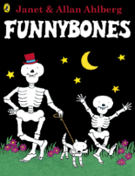
Exciting books/ web links:

- McDonald’s Nutrition Calculator https://www.mcdonalds.com/gb/en-gb/good-to-know/nutrition-calculator.html
- Polar Explorer Resources – https://www.stem.org.uk/welcome-polar-explorer-programme

Parents as partners:
Could your child write a set of instructions (recipe) explaining how to make a healthy snack such as a salad or healthy pizza?
Explore with your child, do our parents need a different diet to ours? How about sportspeople or people who live in different environments?

