 | Art: Drawing
 | Year Group: 3 | Subject Focus: Art | Term: Autumn 1
Skills:  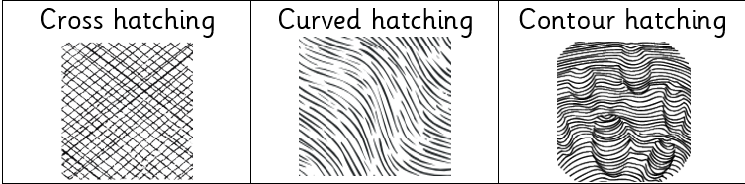  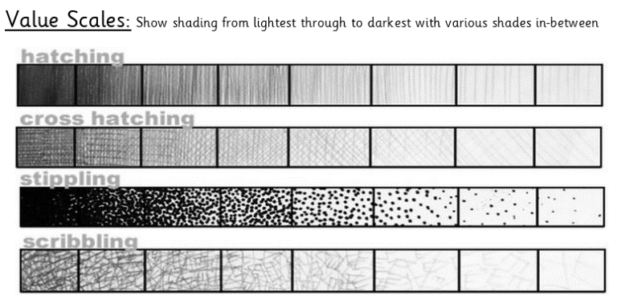  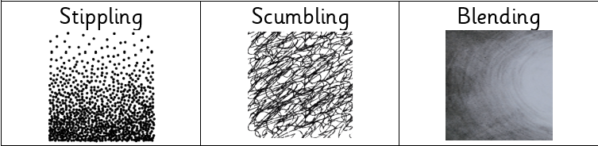  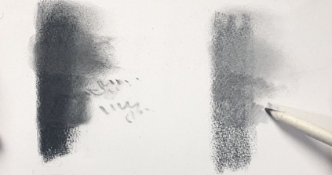  Blending |  | Famous Artwork:  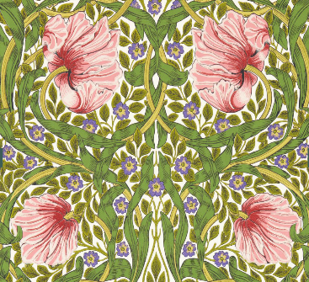  William Morris- Sap Green Pimpernel  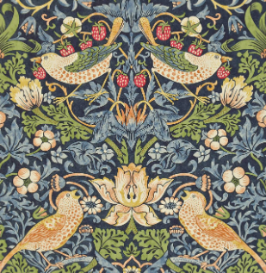  William Morris- Strawberry Thief  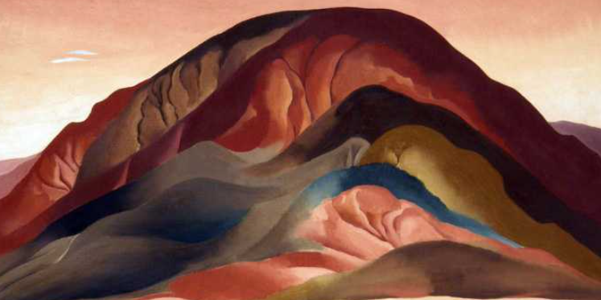  Georgia O'Keeffe, Rust Red Hills | Key words:  About the artists:  WILLIAM MORRIS  - He was born 24th March 1834 and died 3rd October 1896.  - He was an English textile designer, poet, artist and writer.  - No single individual in Britain has had such a lasting impact on the history of British design.  GEORGIA O’KEEFE  - She was born in 1887 and was an American artist who painted nature in a way that showed how it made her feel.  - She is best known for her paintings of flowers and desert landscapes.  - She was the first female painter to gain respect in New York's art world in the 1920s.
  cross hatching | adding straight, parallel lines, which face in a different direction, over hatching
  contour hatching | similar to regular hatching, but the lines will follow the curves or outline of the subject matter
  curve hatching | small lines which are not straight
  contrast | To draw attention to the piece of art work
  blending | rubbing or smudging to create a gradual transition to soften lines
  tone / tonal | providing a range of light to dark by shading with pencil
  gradient | gradually transitioning from one hue to another, or from one shade to another, or one texture to another
  pressure | the amount of force applied- this will determine the darkness of the piece
  scale | the size of one object in relation to the other
  tone | the quality of the colour

