 | Art: Drawing
 | Year Group: 1 | Subject Focus: Art | Term: Autumn 1
Skills:  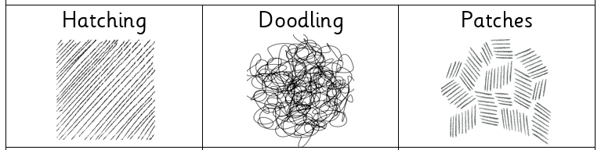  Different types of lines  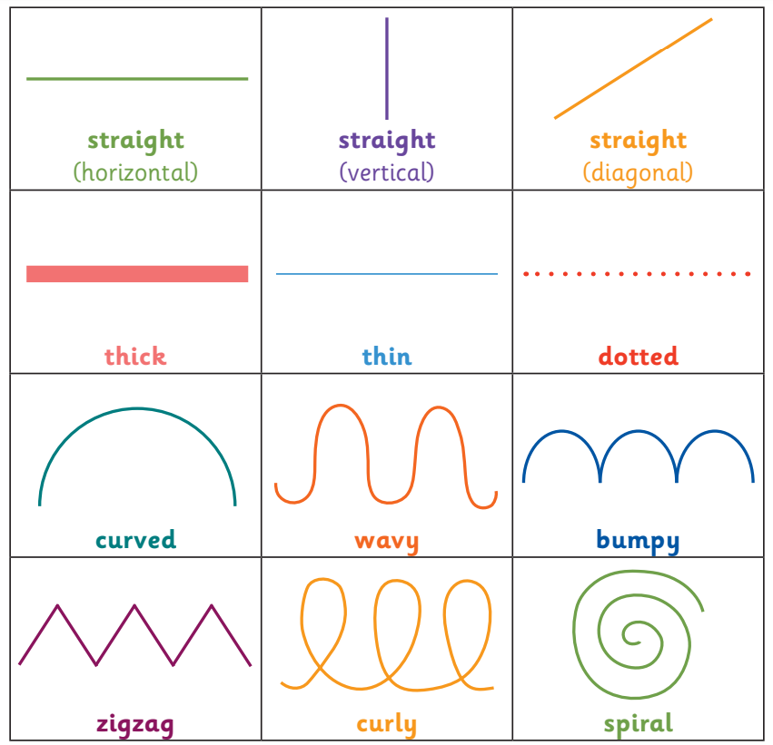 |  | Famous Artwork:  Bridget Riley: Movement in squares  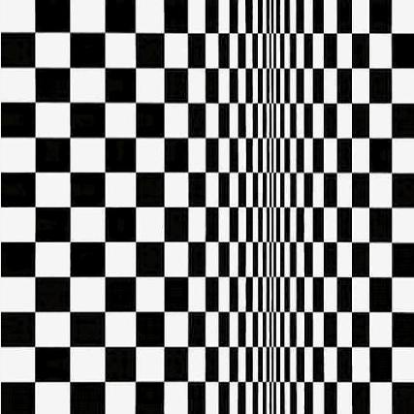  Bridget Riley: Nataraja    Zaria Forman: Greenland No.62   | Key words:  About the artists:  Bridget Riley  - Born in London in 1931.  - Her artwork uses optical illusions, wavy lines: she loved black and white.  - Her art seems to move on the page!  Zaria Forman  - Born in the USA in 1982.  - Travels the world and looks at different climates for her artwork.
  blending | rubbing or smudging to create a gradual transition to soften lines
  doodling | freely drawn patterns and image
  form | the techniques used in a piece of artwork
  hatching | a style of shading with parallel lines
  light | brighter and bolder
  patches | small sections of hatching
  shade | dulling down a colour with black to make it darker
  shadow | darker areas blocked by light
  sketch | drawing an outline quickly with many small strokes
  texture | the surface of a piece of art

