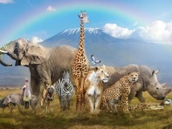 | Animals |  |  | 
 | Year Group: 1 | Subject Focus: Science | Term: Autumn 1
Key facts  - Animals vary in many ways: they have different structures e.g. wings, tails, ears etc. They also have different skin coverings e.g. scales, feathers, hair. These key features can be used to identify them.  - Animals eat certain things - some eat other animals, some eat plants, some eat both plants and animals.  - Humans have key parts in common, but these vary from person to person.  - Humans (and other animals) find out about the world using their senses.  - Humans have five senses – sight, touch, taste, hearing and smelling. These senses are linked to particular parts of the body.  - Humans have both similarities and differences based on their appearance; everyone is unique.  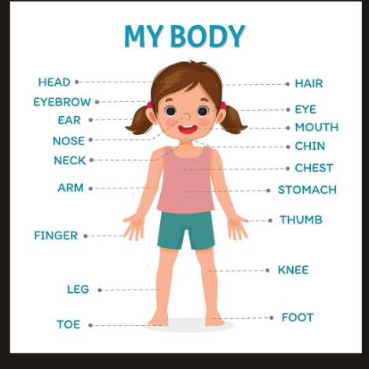 |  | 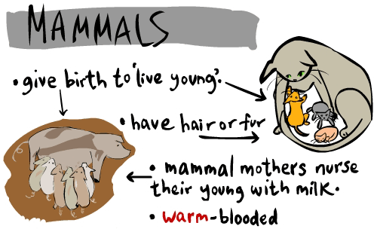  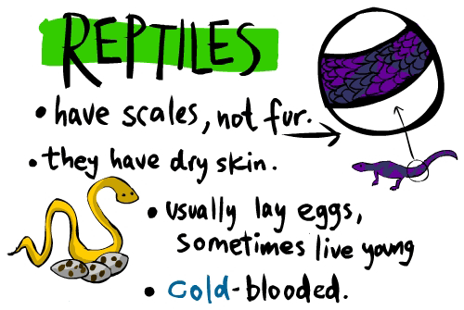  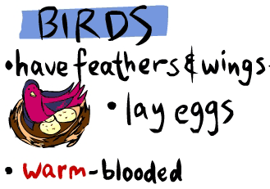  Types of Animals  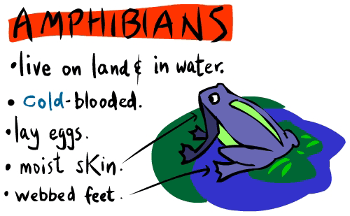  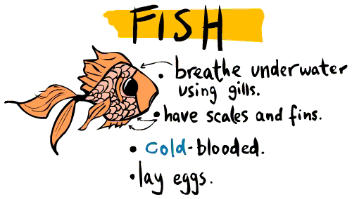 | Key words:
  amphibian | a cold-blooded animal that can live on land and in water: they have a backbone and most lay eggs
  carnivore | an animal that eats meat
  herbivore | an animal that only eats plants
  omnivore | a person or animal eats all kinds of food including both meat and plants
  diet | the kind of food that a person or animal eats
  mammal | an animal that breathes air, has a backbone, and grows hair at some point during its life: they give milk to their young
  reptile | an air-breathing animal that has scales instead of hair or feathers: they have a backbone and most lay eggs
  bird | a warm-blooded animal that has wings, a beak and can typically fly
  senses | there are five senses, they help bodies and brains to gather information
  fish | a cold-blooded animal that lives in water
 |  | Exciting books/ web links:  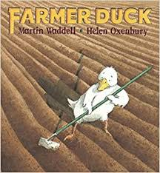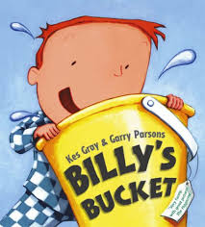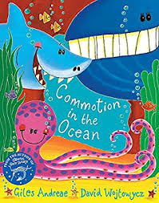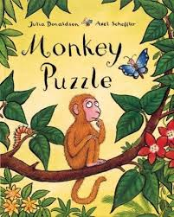  https://www.bbc.co.uk/bitesize/topics/z6882hv  https://planningplaytime.com/preschool-songs-body-parts/  https://www.nurseryrhymes.org/body.html | Parents as partners:  - Visit Tropical World, Temple Newsam Farm or Lotherton Hall and find out what different animals eat.  - Visit Leeds City Museum to see the stuffed animals and skeletons.  - Draw your favourite animal and label its body parts – what other animals are similar?  - Go on a senses hunt, what have you discovered?

