A warm welcome back Year One! I hope you had a lovely six weeks off and are now ready and energised for Year One. We have lots of exciting things planned this half term, and I am looking forward to getting to know all of you. Below you will find out all the information you will need for this half term.
Maths | English | History | Science
In Maths, we will learn how to count forwards and backwards from ten. We will learn how to sort objects according to their shape, size and colour. We will also learn how to count one more than a number and one less.  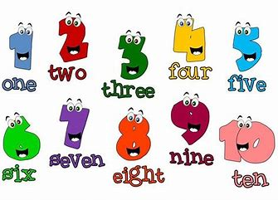 | We will be practising our letter formation in our handwriting sessions and in provision. We will be exploring the story ‘Monkey Puzzle’ and writing our own character description. We will also be learning about nouns, adjectives and verbs. | In History, the focus will be on toys from the past and present. We will compare the materials toys are made from now and in the past and will learn about Ole Kirk, the man who first invented Lego.  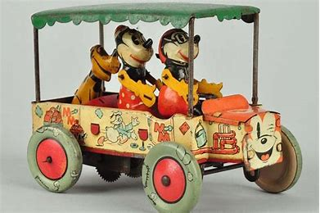 | In Science, we will be focusing on animals including humans. We will learn the different parts of our body and discover which sense is associated with which body part. We will learn about the different animal groups and find out what it means to be a carnivore, herbivore or omnivore.

Important Information –  - Year One will have PE on a Tuesday and Wednesday afternoon. Please ensure children come to school in their full PE kits on these days.  - Please regularly read with your child and write a comment in their book, informing us about how they have read and their success. | Things to know –  - Each Friday, the children will complete a spelling test. Spellings will be sent home on a Friday and should be practised at home throughout the week.  - Reading records and books should be brought back to school on a Thursday. They will be kept on overnight to be changed.  - Children will return home on a Friday with a library book that they have picked – this should be returned on the following Thursday with their book bag.

Any questions you may have, please feel free to come and arrange a time to speak with me. Keep up to date with your child’s learning by going on to the school website and see what they have been busy doing!
Miss Robinson

