Year 4 Newsletter (Autumn 1)

Welcome to Year 4! We hope you had a restful summer break and you are looking forward to the new school year.
Our learning journey
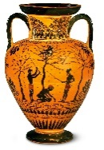  In history, we will be exploring the topic of Ancient Greece, studying Greek life and their influence on the western world. We will discover how Ancient Greece was not a country; it was made up of city states. There were often battles between these city states, but sometimes they would join together against a common enemy. The important city states of Ancient Greece include Athens, Corinth and Sparta. | Our focus this half term in Science is electricity. We will understand that a circuit has be complete to allow electricity to travel all the way around it. All children will build and explore a simple electrical circuit. They will discuss common appliances that run on electricity and investigate which materials are good conductors of electricity and which are not.   | In Maths, the focus is place value, where children will be recognising the value of each digit in a 4-digit number, ordering and comparing numbers beyond 1,000. They will count backwards through 0 to include negative numbers and begin to read Roman numerals. We will then move onto addition and subtraction where children will add or subtract 4-digit numbers and learn how to exchange.  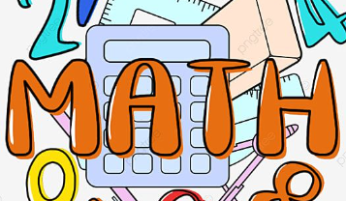 | In English, children will begin by strengthening the foundations of their writing by constructing accurate, well-punctuated sentences and developing greater fluency in their handwriting and spelling. They will revisit key grammar concepts from previous year groups before building more detailed sentences. The children will then explore Greek myths. They will use their understanding of these myths to write their own inspired by Theseus and the Minotaur.  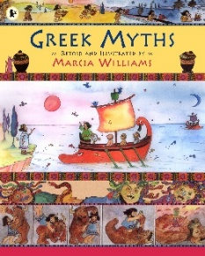

Diary Dates:  PE will take place on a Monday and Tuesday. Children should come to school wearing their PE kits on these days. PE Kits should consist of black, navy or grey tracksuits or shorts (no logos) and a t-shirt in their house colour.  Friday 18th September – Information Morning  Friday 9th October – Harvest Festival  Wednesday 21st October – Ancient Greece Day (more information to follow)  Wednesday 16th – Friday 18th December – Herd Farm (more information to follow) | Class routines:  - The children are expected to read at home every night. Reading records and books should be brought to school every day so that a member of staff can read with them in school. These reading books will be changed on a Friday if the reading record has been signed.  - Each Friday, the children will complete a spelling quiz. The spellings focus will be sent home on a Friday, ready to learn for the following Friday. The children will need to practise these at home (and at school) on a regular basis.  - Pupils should log onto TTRockstars to improve their times tables knowledge. This is constantly monitored as well as accessed in class to prepare the children for their Multiplication Times Table Check in June.

Finally, please remember to log onto the class page on the school website to keep up to date with our latest news or by accessing Reach More Parents.
Mrs Coombes and Mrs Middleton

