 | Electricity |  |  | 
 | Year Group: 4 | Subject Focus: Science | Term: Autumn 1
Key facts  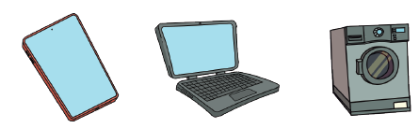  Lots of appliances around our house use electricity to work.  Most big appliances in our house have to be plugged in. These are powered by mains power. Some smaller appliances can be powered by batteries. Some appliances have batteries that need to be charged by mains power.  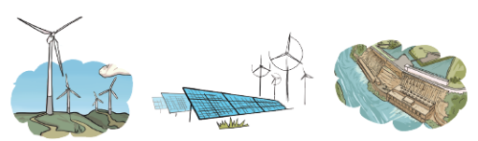  Mains power is produced mainly in a gas, coal, or nuclear power station. Wind turbines, solar panels and hydroelectric dams are also used to produce mains power but are not used as often.  The electricity then travels from the power stations to our houses through overhead wires and pylons. We use the electricity in our house by plugging the appliance into a plug socket. Finally, the electricity enters the appliance’s electrical circuit through the wires. |  | 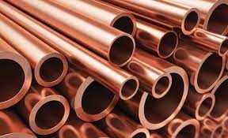  Conductors are substances that electricity can pass through easily. Copper, iron and steel are good conductors.  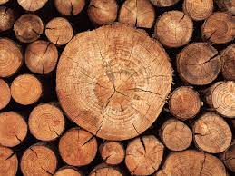  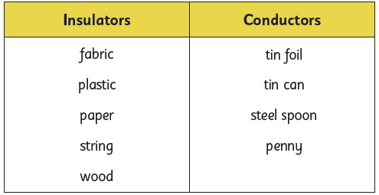  Insulators are materials that do not allow electricity to pass through. Plastic, wood, glass and rubber are good insulators and this is why they are used to cover materials that carry electricity. | Key words:  Parents as partners:  - Where do we use electricity in our everyday lives?  - What if there was no electricity?  - Where can we find switches in our school/home?  - Why are insulators just as important as conductors?  If you enjoy making circuits and learning about electricity, you might like a career (job) working as:  - An electrical engineer (works with equipment that uses electricity)  - An electrician (installs and maintains electrical equipment)  - A renewable energy engineer (works on environmentally conscious energy production)
  electrical | an invisible type of energy made from tiny moving particles called electrons
  circuit | a complete circular path that electricity flows through
  components | the parts of a circuit
  cell | a small item used to power small appliances
  appliance | a machine or tool that runs on electricity to do a specific job, usually around the home
  switch | a device for making and breaking the connection in an electric circuit
  current | the steady flow of tiny electric charges moving through a wire or circuit
  conductor | a material that allows electricity to pass through it
  insulator | a material that does not allow electricity to pass through it
  crocodile clip | a spring, loaded clip that creates a temporary electrical connection
Exciting books/ web links:
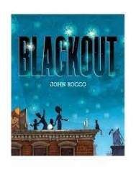
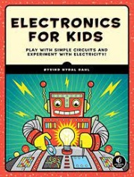
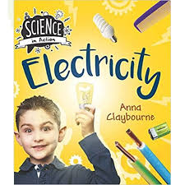

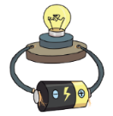  Circuits and Switches  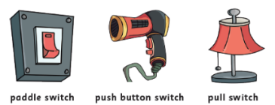  The circuit has to be complete to allow the electricity to travel all the way around it.  When we put a switch in an electrical circuit and turn it to the on position, it completes the circuit and allows electricity to flow around the circuit. When we turn the switch to the off position, this creates a break in the circuit meaning the electricity cannot flow anymore and the appliance will not work. |  | Did you know?  Thomas Edison was an American scientist who is credited with inventing the light bulb.  

