 | Art: Drawing
 | Year Group: 4 | Subject Focus: Art | Term: Autumn 1
Skills:  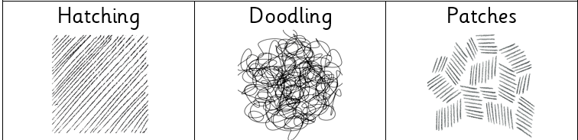  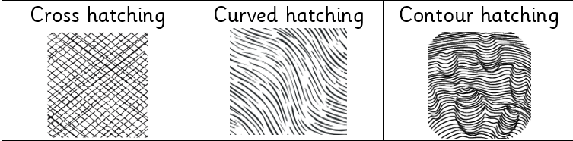  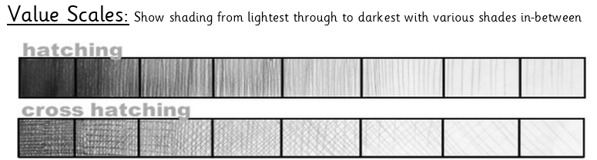  Tone to add definition:  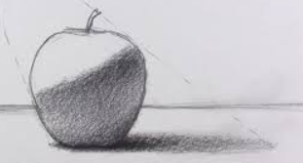  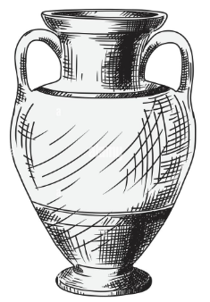  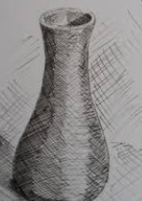 |  | Famous Artwork:  Henri Matisse, Open Window  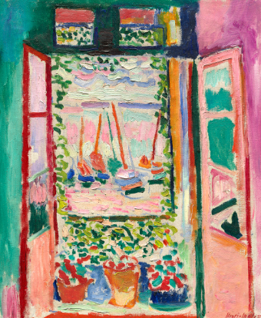  Wassily Kandinsky, Farbstudie Quadrate  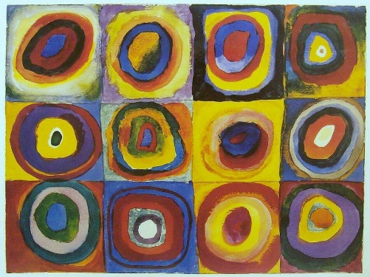  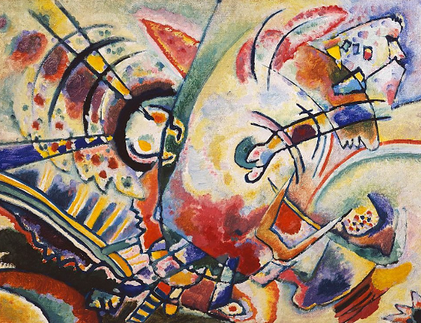  Wassily Kandinsky, Non-Objective | Key words:  About the artists:  HENRI MATISSE  - Henri Matisse was born on December 31st, 1869.  - He was a French artist and is recognised as one of the leading figures in modern art.  - Matisse and Picasso were very good friends and were often compared.  WASSILY KANDINKSY  - Wassily Kandinsky was born in 1866 in Moscow, Russia.  - He is well-known for creating abstract paintings which were inspired by music.  - Kandinsky had a rare condition called synaesthesia where he saw colours when he heard music and heard music when he painted.
  cross hatching | adding straight, parallel lines, which face in a different direction, over hatching
  contour hatching | similar to regular hatching, but the lines will follow the curves or outline of the subject matter
  curve hatching | small lines which are not straight
  hatching | used to create tonal or shading effects by drawing (or painting or scribing) closely spaced parallel lines
  blending | rubbing or smudging to create a gradual transition to soften lines
  tone / tonal | providing a range of light to dark by shading with pencil
  proportion | the different sizes of the individual parts that make up one object
  pressure | the amount of force applied- this will determine the darkness of the piece
  technique | various methods used by artists to create artwork
  precision | to be exact and use accuracy

