Year 6 Newsletter (Summer 2)

Welcome back to Blackman Class in year 6! Our final half term of primary school has arrived and we have many exciting moments to look forward to.
Our learning journey
This half term we will be focusing on history in our topic lessons. We will learn all about Slavery throughout history – focusing primarily on the Atlantic Slave Trade.  We will be investigating what slavery is, what the Atlantic slave trade was, how and why African slaves were transported to America and how the slave trade was abolished.   | In Science, we will finish our unit on evolution. Then we are finding out all about light. We will learn about how light travels, how we see things, different light sources and also show an understanding of shadows.    During our science unit, we will be completing several investigations and taking our science work outdoors.  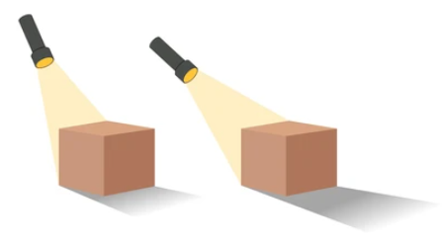 | In our Maths lessons, we will be focusing on time. This will include reading and interpreting timetables in preparation for high school.    We will also be working on problem solving and completing investigations linked to this.  As well as this, we will be consolidating our arithmetic skills in preparation for year 7 maths.  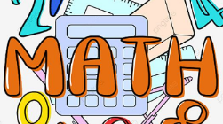 | In English, we will be studying Macbeth.    There will also be many free writing opportunities which give the children the chance to show off their writing skills when writing independently.  
Diary Dates:  Most pupils in year 6 will be visiting their high schools in order to help with their transition in September. If you have not received any communication from high school, please contact school for details. The children will not be in Cross Gates during these days.  - Temple Moor: Wed 8th / Thu 9th July  - John Smeaton: Wed 1st / Thu 2nd July  - Leeds East: Wed 1st July  - Bishop Young: Wed 1st July  - Heckmondwike: Tue 7th July  - North Halifax: Fri 3rd July  - Crossley Heath: Fri 3rd July | Class routines:  - The children are expected to read at home every night and have their reading record signed by an adult. This is the single most useful thing that parents can do to support their children’s learning.  - Each Friday, the children will complete a spelling and mental maths test. The spellings and maths focus will be sent home on a Friday, ready to learn for the following Friday. Please work on these at home.  - Pupils should also continue to log onto TTRockstars to improve their times tables knowledge.
Thank you for your continued support,
Miss Wilson & Mrs Lister

