 | Animals including Humans |  |  | 
 | Year Group: 5 | Subject Focus: Science | Term: Summer 2
Key facts  - Humans change as they develop in to old age.  - Gestation periods vary in different mammals.  - There are names for humans at different stages in their life - baby, child, adolescent, adult, elderly adult/senior.  - Some changes occur rapidly, like those experienced in puberty and adolescence – for example, height.  - Everyone experiences puberty at different points.  - The need for increased washing and personal hygiene to prevent body odour is crucial. |  | 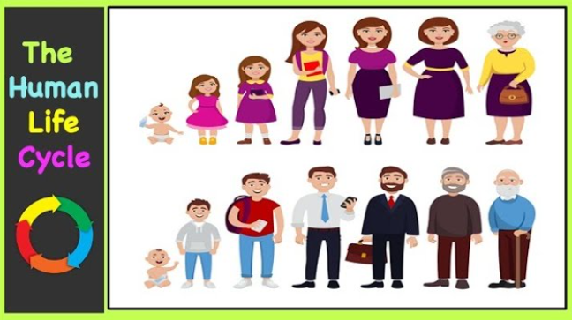  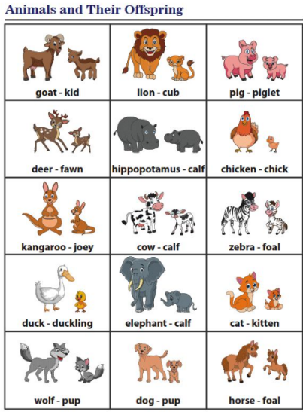  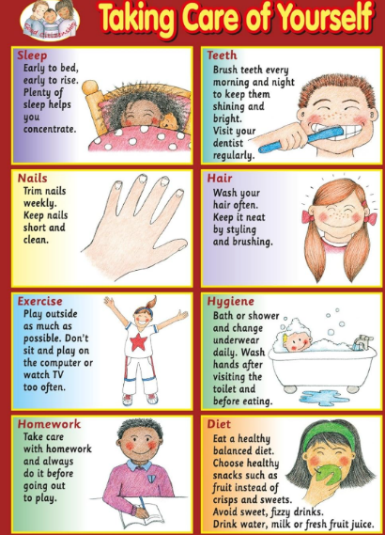 | Key words:
  adolescent | The process of developing from a child to an adult
  elderly | A person in the later stage of life
  womb | An organ in a female where a foetus develops
  death | The end of life for a living thing
  development | Changing into a new stage
  foetus | The unborn offspring while it is growing
  gestation | The time of developing inside a womb
  life cycle | The series of changes in a lifetime
  puberty | The time when a child experiences changes to their body in preparation for being an adult
  young | Having lived for a short period of time
Did you know?
Your body changes in different ways at different times in your life.
All changes to your body, as you grow, are normal.
Some changes might happen at different ages to your friends.
You could join the medical profession as a doctor or nurse when you are older.
 |  | 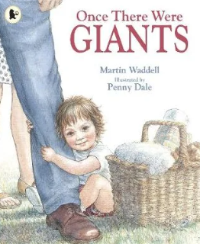  Exciting books/ web links:  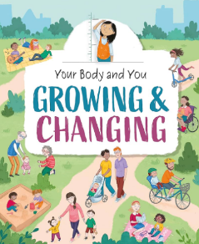  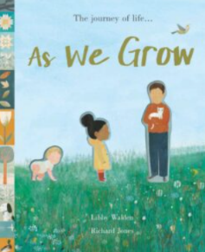 | Parents as partners:  Help your children learn the names of different animals and their babies.  Discuss any concerns that your child might have, about their body changing, with them.  Read books about changes and puberty.  Create a research page about animals and their gestation periods.

