 | D&T – Mechanical Systems: Pop-up book
 | Year Group: 5 | Subject Focus: DT | Term: Summer 2
Key facts:  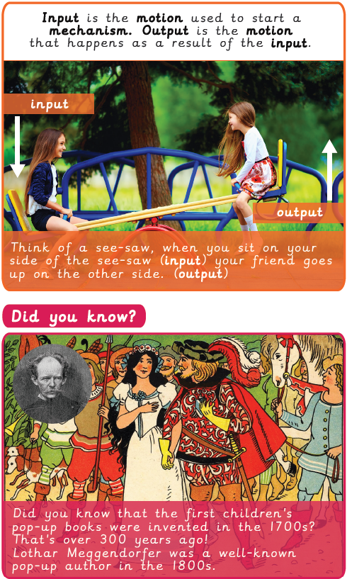  The work of Paul Johnson  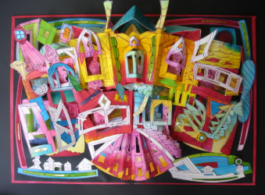 |  | Technical Knowledge:  Lever:  A lever can be used in a pop-up book. It is a mechanism where a bar moves around a fixed point or pivot.  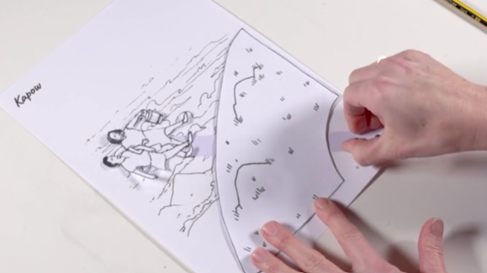  Slider:  A slider can also be used in a pop-up book. It is part of a mechanism which allows an object to move from side to side or up and down.  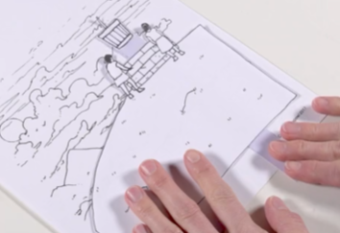 | Key words:  .    Real life:  Paul Johnson is a book artist and teacher in the United Kingdom. He is best known as a pop-up and movable book artist and for his work as a teacher of book art and children’s literacy.
  criteria | A set of points to achieve the end goal.
  design brief | A description of what you are going to design and how it will work
  input | The motion used to start a mechanism
  mechanism | A system of parts working together
  model | The form of an object
  motion | The movement an object makes when controlled by an input
  reinforce | To make a structure stronger, by adding another element or material
  research | Neat, correct shape, with no mistakes
  function | How an object works
  output | The motion that happens as a result of starting the input

