
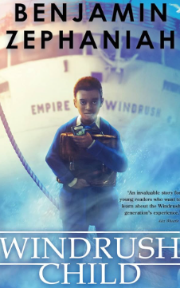
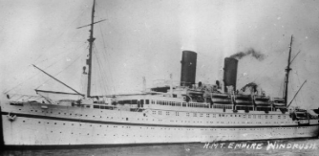

https://www.google.com/url?sa=i&url=https%3A%2F%2Fwww.etsy.com%2Fuk%2Flisting%2F1477679581%2Fsummer-png-transparent-non-transparent&psig=AOvVaw2fl3BkaGXQlJgCJKfQLgXZ&ust=1748794312520000&source=images&cd=vfe&opi=89978449&ved=0CBQQjRxqFwoTCKCritCMzo0DFQAAAAAdAAAAABAE

Dear parents and carers,

Welcome to the start of the new (and final) term – Summer 2, I hope you have had a restful half term break and your child is looking forward to the new half term! There are many exciting things to look forward to!

Year Five
Newsletter
June 2026

Science: ‘Animals Including Humans’. We will be learning about the human life cycle, and the changes humans go through during their lifetime.
PSHE: We will be learning about careers and finance.
DT: We will be learning about mechanisms and creating pop-up books!
Music: We will be working on composition, and creating our own piece of music!
French: We will be consolidating all of our learning so far, focusing on pronunciation and accuracy!
RE: We will be learning about how different faiths have different values.
Computing: Microsoft Word skills.

Maths
In maths, we will be learning how to add and subtract decimals. We will then move onto learning to multiply and divide numbers by 10, 100 and 1000. We will also look at volume, converting units, and negative numbers.

English and Reading
In reading we are starting a new book called ‘Windrush Child’ by Benjamin Zephaniah. In English, we will be studying and performing poems by Valerie Bloom. We will then be working on writing a historical narrative based on the Windrush child.
Topic – Windrush
In history this term, our topic is Windrush! We will learn all about the effects on Britain after WW2, and why people came to the UK. We will focus particularly on those who came from Jamaica on the Empire Windrush, the troubles they faced, and the work they did to rebuild the country post war.
HOMEWORK - Please ensure that your child practises words from their spelling lists, reads daily for 10 minutes and completes online learning tasks such as TTRockstars, purple-mash and mathsbot!
PE – We are excited to be continuing swimming lessons this term, which will be on a Monday afternoon. Please ensure your child comes to school with their swimming costume/shorts and brings a towel. We will also have PE this term on a Wednesday and cricket on a Thursday. Please ensure your child brings their PE kit to school with appropriate trainers. All long hair must be tied up and jewellery must be removed during PE.

