Year 3 Newsletter (Summer 2)

Welcome back! I hope you had a lovely break and are ready for all of our wonderful learning this last half term.
Our learning journey
History  In History, we will explore Ancient Civilisations including the Indus Valley, Shang Dynasty and Sumer. Pupils will learn about their key achievements and make comparisons to deepen their understanding of how these early societies developed and influenced the world.  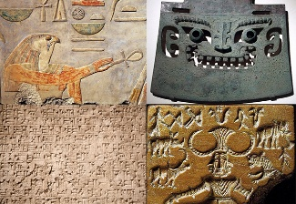 | Science  We will complete our learning on plants then moving swiftly on to light: observing how it reflects off surfaces. Pupils will learn that darkness is the absence of light and understand how shadows are formed when an object blocks light from a source.  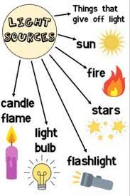  . | Maths  In Maths, we will focus on identifying and describing 2D and 3D shapes, recognising angles and understanding their properties. We will also explore statistics by collecting data and presenting it using bar charts and pictograms to build confidence interpreting information.  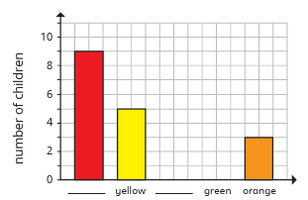 | English  In English, we will focus on two writing purposes: to entertain and to inform. Using The Iron Man, pupils will create atmosphere through figurative language. They will also write a non-chronological report to inform, based on an ancient civilisation of their choice.  

Other:  - PE will take place on a Monday and Thursday. The children need to come to school in their uniform on these days and bring the full PE kit.  - Week beginning Monday 15th June – Sports and Wellbeing week  - Wednesday 17th June – Sports Day  - Friday 3rd July – Summer Fair | Class routines:  - The children are expected to read at home every night. Reading records and books should be brought to school every day so that a member of staff can read with them in school. These reading books will be changed on a Friday if the reading record has been signed.  - Each Friday, the children will complete a spelling quiz. Spellings will be sent home of a Friday and should be practised at home.  - Pupils should continue to log onto TTRockstars to improve their times tables knowledge. This can be done through ‘Jamming’ focusing on our 2,3,4,5,8 and 10 times tables.

Finally, please remember to log onto the class page on the school website to keep up to date with our latest news: https://www.crossgatesprimary.co.uk/class-pages/ or by accessing RMP.
Miss Croft

