 | Ancient Civilisations |  |  | 
 | Year Group: 3 | Subject Focus: History | Term: Summer 2
Key facts  - The Shang Dynasty was from 1600 to 1046 BC. The Shang were known for their amazing discoveries.  - The Sumer Civilisation was from 4500-1900BC.  - The Indus Valley was a Bronze Age Civilisation from 3300- 1300 BC. |  | 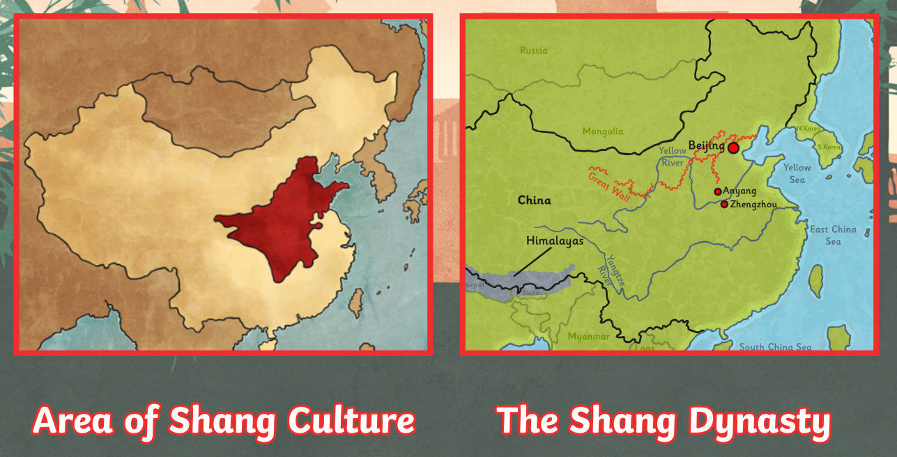  The Shang Dynasty was a time of rule under the Shang family in China from around 1600 BCE to 1046 BCE. Their empire reached far into the East China Sea, beyond the Yellow River. The Shang way of living and its traditions reached very far throughout China.  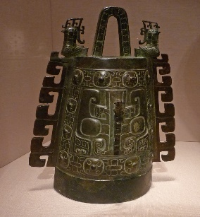  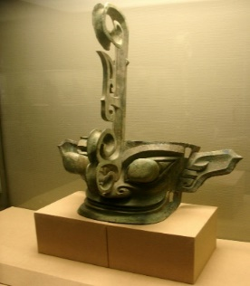  bell  mask  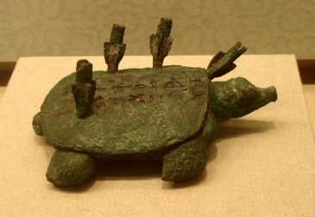  The Shang Dynasty is known as China’s Bronze Age. The reason for this is the sheer skill they showed in making beautiful bronze art. | Key words:
  civilization | The process by which a society or place reaches an advanced stage of social and cultural development.
  dynasty | A line of hereditary rulers of a country.
  Indus Valley | A region in the North-Western part of India.
  Shang Dynasty | The first recorded Chinese Dynasty.
  ancient | From a time long ago.
  Sumer Civilisation | Sumer, site of the earliest known civilization, located in the southernmost part of Mesopotamia (Western Asia).
  culture | The ideas and social behaviour of particular people or society.
  bronze | A metal alloy made from a mixture of copper and tin. It is a much harder and more long-lasting material than stone or copper alone.
  empire | A group of countries ruled by a single person.
  timeline | A graphical representation of a period of time on which important events are marked.
Key people
- The First Shang King was known as Tang, Tang Cheng or Tai Yi.

- Shangdi - The king was believed to have a special connection with the dead, royal ancestors. This made the king the closest human being to a god.
Exciting books/ web links:
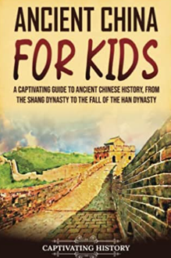
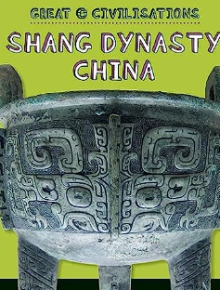

https:///www.booksfortopics.com/booklists/topics/history/ancient-civilisations-shang-sumer-indus/
Parents as partners:
- Make a model of a Chinese dragon out of recycled material.
- Create your own Shang Dynasty bunting. Put information about various aspects of the Shang Dynasty on each flag.
- Create your own family tree to show your own family’s ancestry.
h

