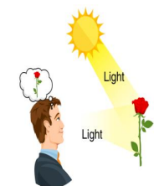 | Light |  |  | 
 | Year Group: 3 | Subject Focus: Science | Term: Summer
Key facts  - We need light in order to see. Without light, there is darkness.  - Light can come from different sources: the sun, other stars, lamps, lightbulbs and fire.  - Light can be reflected from shiny surfaces, such as mirrors and polished metal.  - When light is reflected from a surface, it changes direction. 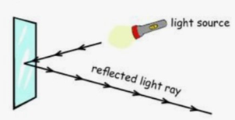 |  | Our five enquiry types:  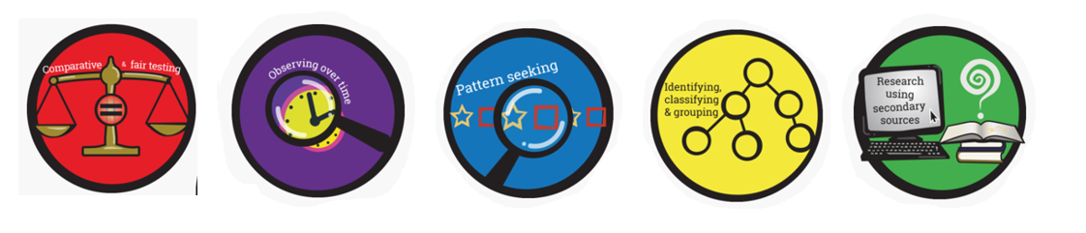  Working Scientifically Skills:  In this unit we will be:    Asking Questions    Making Predictions    Observing    Interpreting and Communicating Results    Evaluating | Key words:
  Natural | Artificial
  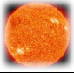  Sun | 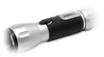  Torch
  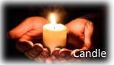 | 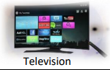
  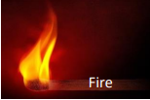 | 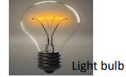
  Dangers | Anything that has the potential to cause harm, injury or damage.
  Light source | Something that produces light.
  Dark | The absence of light.
  Shadow | A dark shape or outline of something that is made when light is blocked.
  Reflect | When a light hits a surface and ‘bounces back’ to our eyes.
  Mirror | A surface coated with glass, which reflects a clear image.
  Luminous | An object that gives off or makes its own light.
  Sunlight | Light produced by the sun.
  Absence of light | Refers to darkness: no or little light.
  surface | The outside part of the uppermost layer of something.
Parents as partners:
- Investigate shadows. Have fun looking at where and when shadows form, how you can make them bigger or smaller.

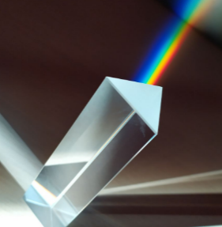
- You can make a rainbow at home. On a sunny day, experiment with placing a glass of water so that sunlight can pass through it but have something plain (paper or a blank wall) placed behind the glass so that you can see the colours.

Exciting books/ web links:
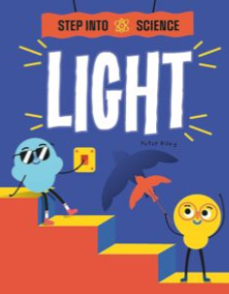
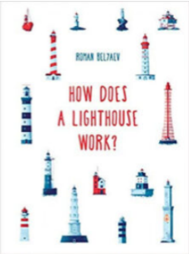
- Science Kids - Light
- BBC Bitesize - Light
- National Geographic Kids - Light

