 | DT: Electric Poster
 | Year Group: 3 | Subject Focus: DT | Term: Summer 2
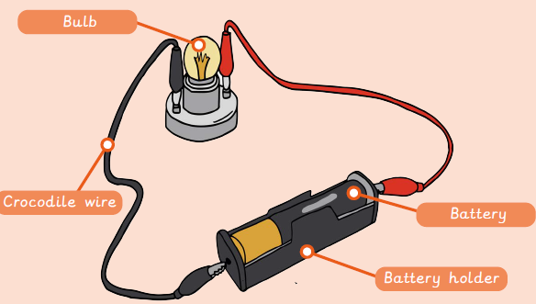  An electrical system is a group of parts (components) that work to transport electricity around a circuit.  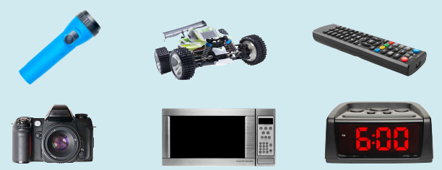  An electrical product is an object that uses an electrical system to make its different parts work.  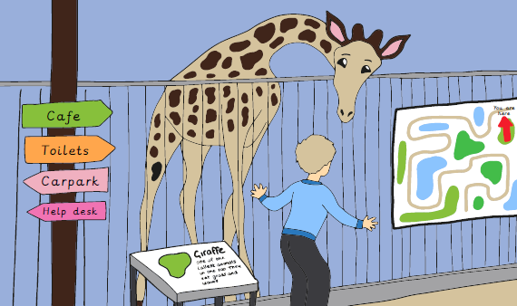Information design is one area (field) of design. It covers all items and products that are developed to give the public further information. |  | Design – Make – Evaluate | Key words:
  Key Knowledge
  1 | An electrical poster is an object that uses an electrical system to make its different parts work.
  2 | An electrical system is a group of parts (components) that work to transport electricity around a circuit.
  3 | Information design is one area (field) of design. It covers all items and products that are developed to give the public further information.
  4 | The purpose of information design is to see how to get somewhere, explain what something is or to learn something new.
  5 | Design criteria are a set of instructions for a project.
  6 | A bulb can be used to add aesthetic appeal or draw public attention.
  7 | The final design is the best and last in a series of designs.
  8 | The design cycle includes research, design, make and evaluate.
  bulb | A component which gives light when electricity passes through it.
  battery | A cell or connected group of cells which store electrical energy.
  circuit | A collection of components which make an electrical system.
  circuit component | One of several parts that complete a circuit (e.g. bulb).
  information design | Facts that are displayed in a visually appealing way and are easy to understand.
  initial ideas | A series of sketches to solve a problem or design a product.
  information | Facts that we learn or research about something.
  public | People in our community.
  research | Using different media (e.g. newspapers, books, online searches) to collect information about a subject.
  wire | A thin piece of copper thread which conducts electricity to connect circuit components together.
?

