 | Living Things and their Habitats
 | Year Group: 4 | Subject Focus: Science | Term: Summer 2
Key facts  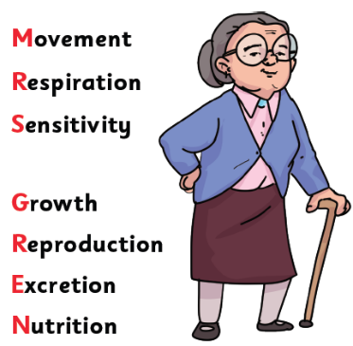  - There are seven things that all living things do, we call these life processes. All animals, including humans, do these and plants do too! We can remember them with the help of Mrs Gren!  - We can group animals into five different groups based on their characteristics.  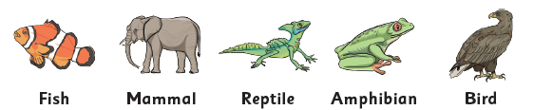 |  | Working Scientifically Skills  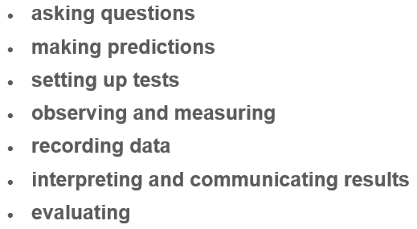    Children will persist in developing the above working scientifically skills throughout our sessions. In each lesson, a particular skill will be the focal point as they engage in their investigations. Our emphasis will be on demonstrating and modelling so that the children develop these skills further, for example interpret data and communicate results effectively. | Key words:
  classification | the process of sorting objects, living things, or information into groups based on their shared similarities and differences
  sensitivity | the ability of living things to detect and respond to changes in their environment
  respiration | the process that all living things (plants and animals) go through to create the energy they need to live, grow and move
  excretion | the body's essential process of removing waste products
  nutrition | how food works in the body and provides the fuel needed to grow, play and learn
  migrate | to move from one home, region or country to another
  hibernate | a deep, long sleep that some animals take during the winter to survive cold weather and lack of food
  classification key | this is where plants or animals are placed into groups according to their similarities
  human impact | the impact humans have on the environment and habitats
How else can we group animals?
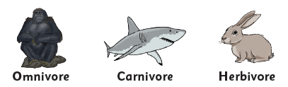
- We can also group animals based on the types of food they eat.

- We can also group animals based on whether they have a backbone (spine) or not.
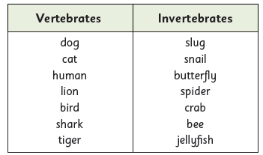

 |  | Exciting books / web links:  Habitats (nationalgeographic.com)  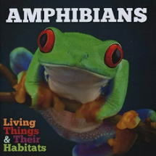  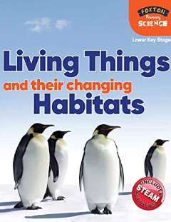  Living things and their habitats - Year 4 Science - BBC Bitesize  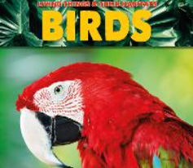  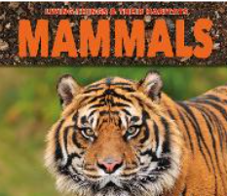 | Parents as partners:  - Discuss and describe some of the features or characteristics of the living things you see.  - Discuss the effects that human activity has on the environment and some of the dangers this can have on living things.  

