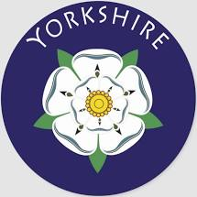 | Yorkshire |  |  | 
 | Year Group: 4 | Subject Focus: Geography | Term: Summer 2
Key facts  - England is a country in the United Kingdom, in the continent of Europe.  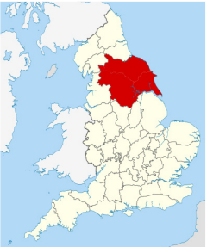  - Yorkshire is a county in North East England.  - The city of Leeds is Yorkshire’s largest city and is now the leading centre of trade and commerce in the region.  - Traditional industries included sheep, farming, textile manufacturing, coal mining and the steel industry.  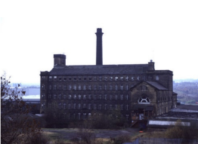  - There is much evidence of canals, mines, wool mills and heavy industry throughout Yorkshire. |  | - There are 109 counties of the UK.  - There are 48 counties in England.  - Yorkshire is made up of 4 counties: North Yorkshire, West Yorkshire, South Yorkshire and East Yorkshire.  - The main cities of Yorkshire are Leeds, York, Sheffield, Bradford, Middlesbrough and Hull.  - The main towns in Yorkshire are York, Ripon, Leeds, Bradford, Kingston upon Hull, Scarborough, Harrogate, Skipton, Whitby and Hebden Bridge.  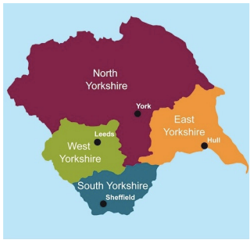  - The main rivers in Yorkshire are the River Swale, Ure and Nidd.  - The main mountains and hills in Yorkshire are Whernside, Ingleborough and Pen-y-ghent | Key words:
  atlas | a book of maps
  capital city | the city where the government sits - London is the capital city of England and the UK
  cartography | the making of maps
  county | a small area of the UK containing lots of towns and villages
  human geography | the type of geography dealing with how human activity affects or is influenced by the earth's surface.
  Great Britain | England, Scotland and Wales
  key | gives you the information needed for the map to make sense
  landmark | a feature of the landscape or area that is easily recognised
  land use | how humans have managed land for different activities
  physical geography | the type of geography dealing with natural features
Did you know?  - Tourism is significant in the region.  - North Yorkshire has an established tourist industry.  - Previous industrial use of land has changed over time to nature reserves, shopping centres, bio mass and solar and wind power. |  | 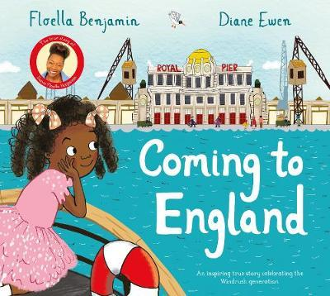  Exciting books/ web links:  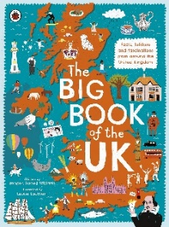  Sites to Visit in Yorkshire | English Heritage (english-heritage.org.uk) | Parents as partners:  - Encourage your child to create some amazing fact cards about Yorkshire.  - Use Google Earth and locate where you are on the map.  - Together, make a poster comparing Leeds and London.  - Create a word search or crossword about Yorkshire landmarks.  - If you could visit somewhere in Yorkshire, where would it be? Look online and create an itinerary for a weekend visit. How many different activities could you include?

