
Year 2 Summer 2 Newsletter
Welcome back!
As we enter our final half term, let us share with you what we will be learning.
In Maths, we will be learning about fractions and how to tell the time.
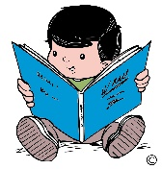
In English we are using the book ‘Flat Stanley’ to inspire us to write a letter. We will also be writing an Acrostic Poem.
In Science, we will continue to develop our skills and enquiring minds.
In Music we will be looking at tunes and improvising singing. PSHE sees us learning about what keeps us healthy. In RE we will continue to learn about how symbols are used to welcome new life.
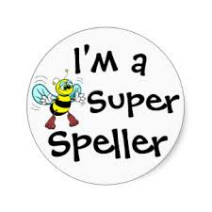
In DT, it is cooking and nutrition and we will be planning and making wraps, while Computing sees us presenting ideas and in French, we will continue to learn nursery rhymes.

We will continue to work with our coaches in PE. We would like to remind you again that our PE days are Tuesday and Friday and your child needs to wear their school PE kit on those days. Please do not send your child in branded sportswear or clothing with writing on. We would also request that, in line with school policy, any earrings are removed on these days.
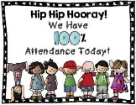
The children will continue to bring home spellings each week, usually on a Friday, that they will need to learn for a test the following Friday. We always appreciate your support with helping your child learn their spellings.
Your child’s regular attendance, as always, is essential. Children find it very difficult to keep up with their work and very quickly fall behind, if their attendance is not consistent. Obviously genuine illness is a different matter.
If you would like to know anything regarding your child in Year 2, please do not hesitate to contact us. We would like to thank you for your continued support.
Mrs. Austin and the Year 2 Team

