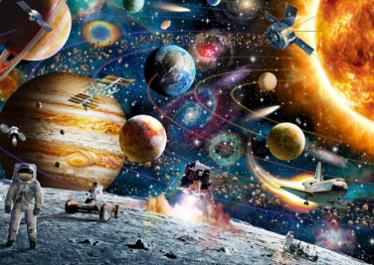
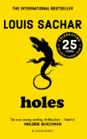


Year Five
Newsletter
April 2026

Science: ‘Earth and Space’. We will be learning about the planets in our solar system, alongside focusing on the Earth, Sun and Moon!
PSHE: We will be learning about drugs, alcohol and tobacco.
Art: We will be exploring mixed-media artwork, and we will create our own piece inspired by the work of Steven Brown!
Music: We will be working on chair drumming!

French: We will be learning how to describe what rooms are, and are not, in our homes.
RE: We will be learning about how different faiths have different values.
Computing: 3D modelling!

Maths
In Maths, we will be learning all about 3D shapes, angles and degrees! We will also look at coordinates and lines of symmetry. In our weekly arithmetic tests, we will continue to work on key arithmetic skills and improve our scores week by week!

English and Reading
In reading, we are starting a new book called ‘Holes’ by Louis Sachar, which is set in a juvenile detention centre called Camp Green Lake!
In English, we will be working on writing a persuasive leaflet all about Camp Green Lake and a non-chronological report about lizards!

Topic – North America!
In geography this term, our topic is North America! We will learn all about the different countries that make up North America and all about the different environmental regions too! We will also learn about time zones around the Earth, the equator and the lines of latitude and longitude!
HOMEWORK - Please ensure that your child practises words from their spelling lists, reads daily for 10 minutes and completes online learning tasks such as TTRockstars, purple-mash and mathsbot!
PE – We are excited to be continuing swimming lessons this term, which will be on a Monday afternoon. Please ensure your child comes to school with their swimming costume/shorts and brings a towel. We will also have PE this term on a Wednesday. Please ensure your child brings their PE kit to school with appropriate trainers. All long hair must be tied up and jewellery must be removed during PE.

Dear parents and carers,

Welcome to the start of the new term – Summer 1, I hope you have had a restful half term break and your child is looking forward to the new half term!

