 | North America |  |  | 
 | Year Group: 5 | Subject Focus: Geography | Term: Summer 1
Key facts  - North America is one the world’s seven continents.  - There are 23 countries in North America—this includes the countries in Central America and the Caribbean islands.  - The three biggest countries are Canada, the United States of America and Mexico.  - North America is the third largest continent by area, following Asia and Africa, and the fourth by population after Asia, Africa, and Europe.  - In North America, the further north you go, the colder it becomes (Canada can be cold and relatively snowy).  - In North America, the further south you go, the warmer it becomes (Mexico tends to be hot and humid because it’s closer to the equator).  - You can use longitude and latitude coordinates to find specific locations. Latitude tells you how far north or south from the Equator and longitude tells you how far east or west from the Prime Meridian.  - The largest city in North America is Mexico City.  - Approximately 500 million people live in North America.  - North America has a varied landscape due to its size. |  | 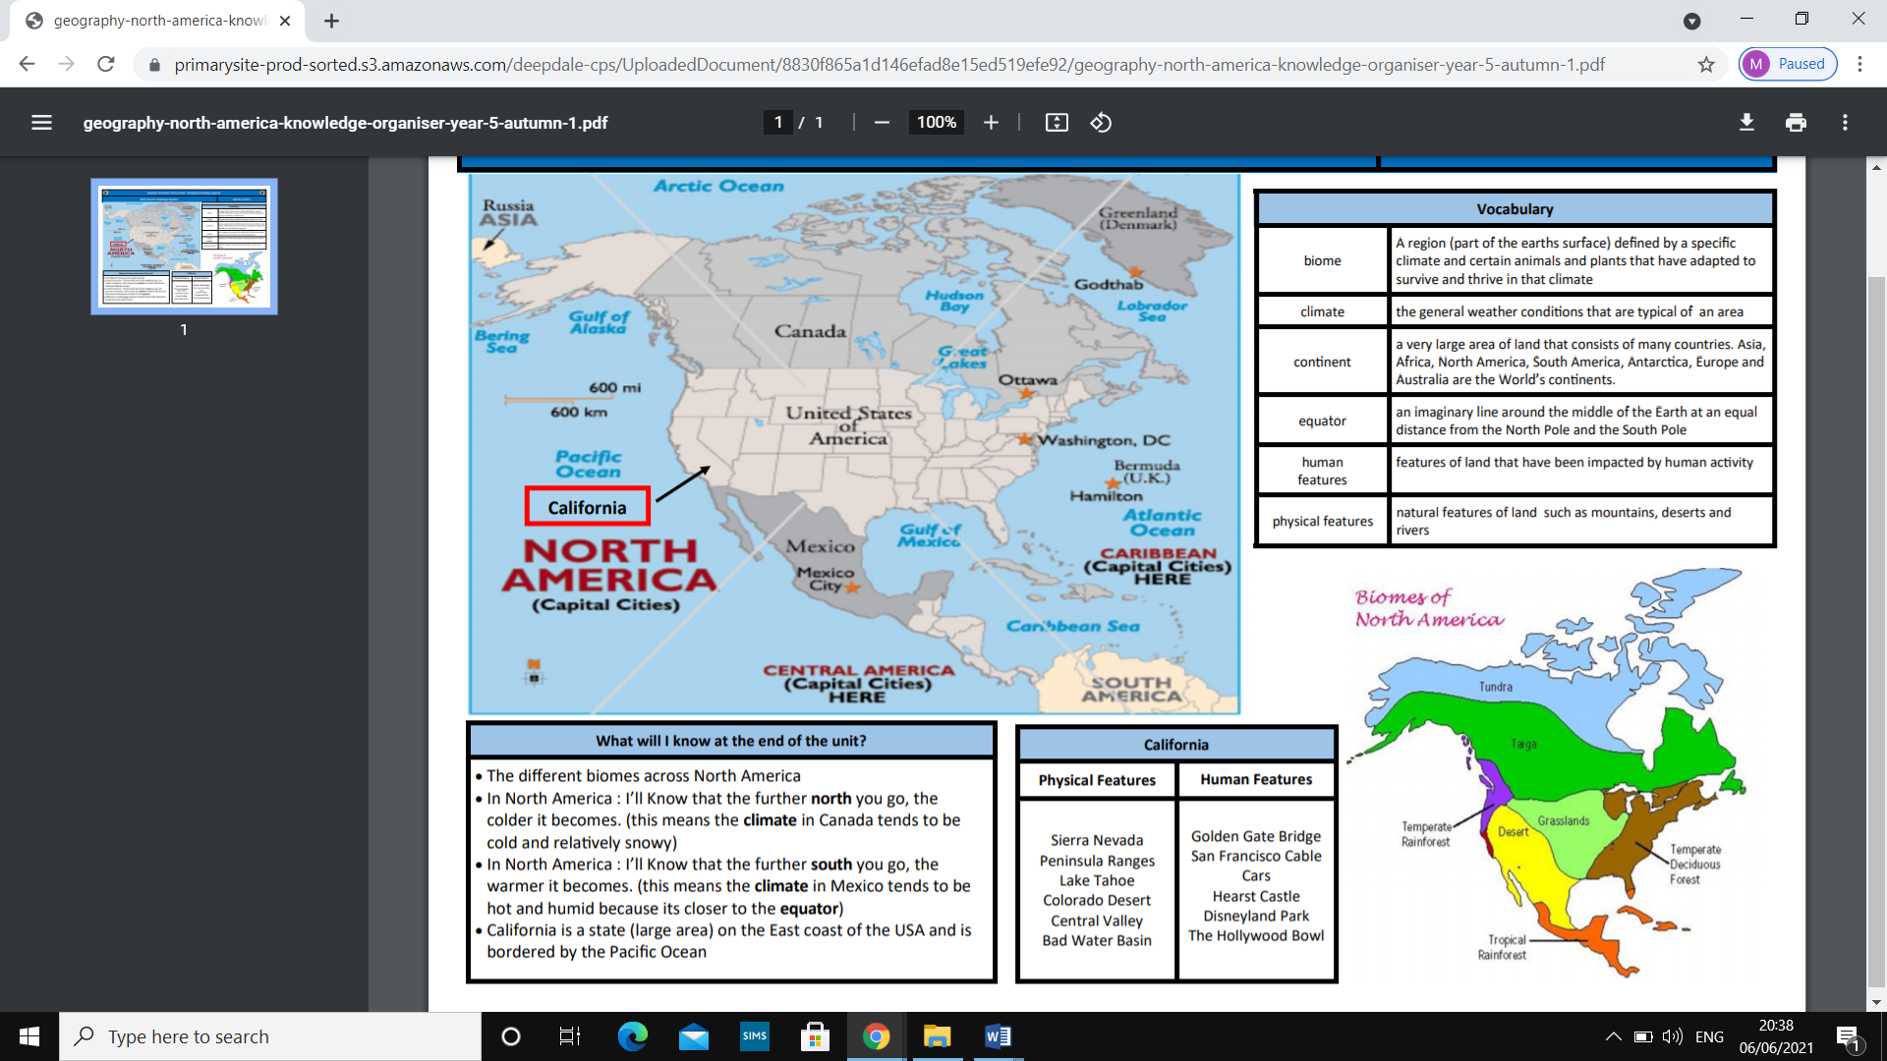  Map of North America  North America has many physical and human features. | Key words:
  North America
  Physical features | Human features
  Grand Canyon  Niagara Falls  Yellowstone National Park  Rocky Mountains  The Great Lakes  Mississippi River  Yucatán Peninsula | Statue of Liberty  Empire State Building  Golden Gate Bridge  Chichen Itza  Disneyland  New York City  The CN Tower  Kennedy Space Center
  biome | a shared physical climate
  canyon | a deep narrow valley with steep sides
  climate | the general weather in an area
  drought | a long period where there is little or no rain
  equator | an imaginary line around the middle of the Earth at an equal distance from the North and South Poles
  lines of latitude  and longitude | invisible lines that cover the Earth, lines of latitude run east to west: lines of longitude run vertically from the North Pole to the South Pole.
  savanna | tropical grasslands, they may have scattered bushes and trees
  temperate forests | forests which experience mild summers and winters
  taiga | the largest land biome with thick forests
  tundra | the coldest biome, a barren region with no trees
Did you know?
There are different biomes across North America which are specific to the plants and animals that live there.
Examples of these biomes are
forest,
rainforest, grassland, tundra,
desert,
savanna
and taiga.
 |  | Exciting books/ web links:  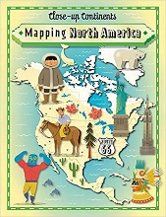    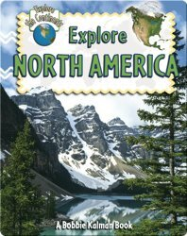  Learn about biomes and lines of latitude:  https://www.bbc.co.uk/bitesize/subjects/zbkw2hv | Parents as partners:  - Encourage your child to create some amazing fact cards about North America.  - Draw, paint a picture or build a model of a famous landmark in North America e.g. The Grand Canyon.  - Christopher Columbus is credited for finding America. Create a fact file or write a biography detailing his achievements.  - Visit some of the websites listed on this page and talk about what you discover:  https://www.kids-world-travel-guide.com/north-america-facts.html  https://kids.britannica.com/kids/article/North-America/353542

