 | Art: Painting and Mixed Media
 | Year Group: 5 | Subject Focus: Art | Term: Summer 1
Key facts:  - Mixed media art uses a combination of different materials.  - The materials used can be anything, like paint, paper, cardboard, photographs, found objects, things from nature – anything!  - It encourages creativity and experimentation by combining materials and techniques into one piece of art.  - The roots of mixed media can be traced back to the ‘Cubist movement’, where artists like Picasso began incorporating collage and other mixed media techniques into their work.  Popular techniques include:  - Collage  - Assemblage  - Painting  - Digital mixed media  Take a look at BBC Bitesize for more information!  https://www.bbc.co.uk/bitesize/articles/z8sg8p3#zb6frmn |  | Famous Artwork:  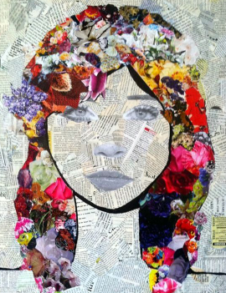  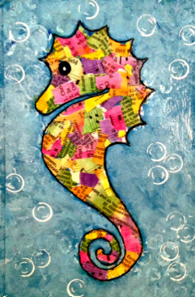  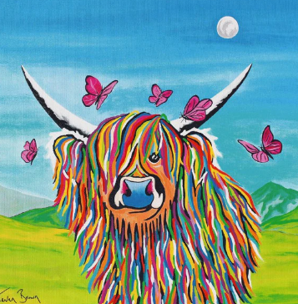  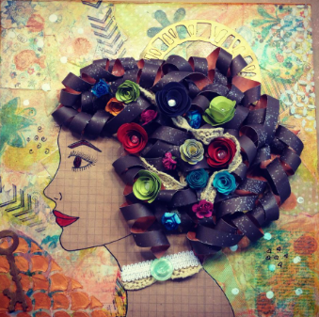 | Key words:  About the artists:  Steven Brown  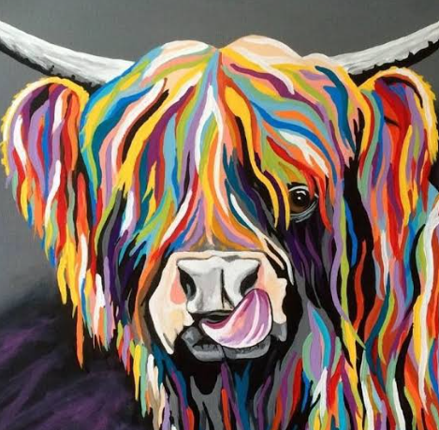  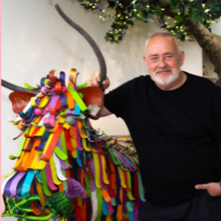  Steven John Brown is a Scottish artist who is known for his Scotland inspired landscapes, culture, fauna and flora, often created with a blend of bright colours
  art | the expression of creative skill, which can be expressed in many ways
  artist | a person who creates art
  mixed media | artwork that uses two or more materials or techniques to create it
  concept | an idea behind a piece of art
  background | the part of the artwork that is behind the main subjects
  technique | the methods an artist uses
  collage | a technique where various materials are assembled
  evaluate | to make a judgement about a piece of art
  medium | the material used to create a piece of art
  composition | the way in which different elements of an artwork are arranged

