 | Earth and Space |  |  | 
 | Year Group: 5 | Subject Focus: Science | Term: Summer 1
Key facts  - Describe the movement of the Earth, and other planets, relative to the Sun in the solar system: the planets revolve/orbit around the Sun. It takes 365 ¼ days for the Earth to complete a full orbit.  - Describe the movement of the Moon relative to the Earth: the Moon revolves/orbits around the Sun. It takes about 27 days for the Moon to complete a full orbit.  - Describe the Sun, Earth and Moon as approximately spherical bodies.  - Use the idea of the Earth’s rotation to explain day and night and the apparent movement of the Sun across the sky: the Earth rotates (spins) on an axis. It takes 24 hours for the Earth to complete a full rotation |  | 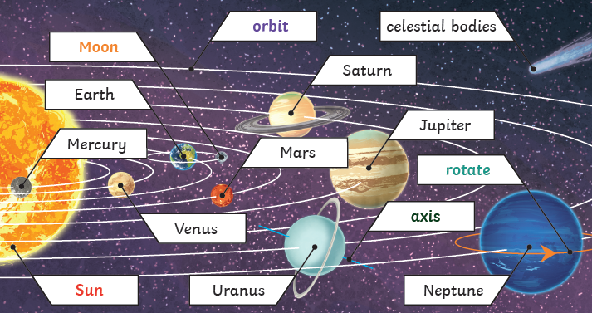  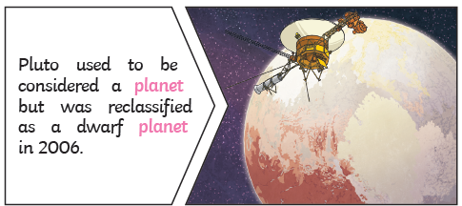 | Key words:
  Earth | The planet on which we live.
  axis | An imaginary line through the centre of an object.
  moon | A natural satellite which orbits Earth.
  orbit | The curved path an object in space takes around a star, planet or moon.
  planet | A large object that orbits a star.
  rotate | To turn on an axis.
  solar system | The collection of eight planets and their moons in orbit around the sun.
  spherical | Shaped like a sphere.
  star | A giant ball of gas held together by gravity.
  duration | The length of time something lasts.
Did you know?

The Moon does not disappear although it does seem to change its shape.

The Moon is not the reason, or part of the reason we have night and day.

The rotation of the Earth causes night and day and its orbit around the Sun gives us a 365¼ day year.

 |  | Exciting books/ web links:  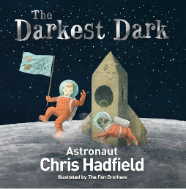  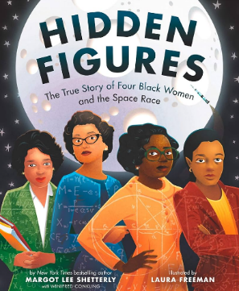 | Parents as partners:  Investigate these websites with your child;  https://www.esa.int/kids/en/learn/Our_Universe/Planets_and_moons/The_Solar_System_and_its_planets  https://spaceplace.nasa.gov/menu/solar-system/

