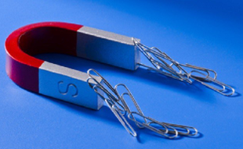 | Forces and Magnets |  |  | 
 | Year Group: 3 | Subject Focus: Science | Term: Spring 1
Key facts  - A force is a push or a pull.  - You cannot see forces, but you can feel and/or see the effects of them.  - Some forces can only be created when objects come into contact with each other. Other forces (magnetism/gravity) can occur at a distance.  - Magnets can attract and repel each other.  - Magnets have a north pole and a south pole.  - When opposite poles meet, the magnets will attract (pull together). When the same poles meet, they repel each other (push away).  - There are different types of magnets e.g. horse shoe, bar magnet, button, ring. |  | Magnets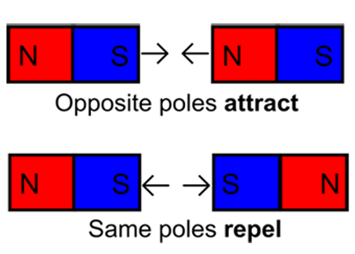  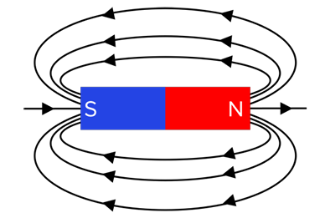  Magnetic Field  Our five enquiry types:  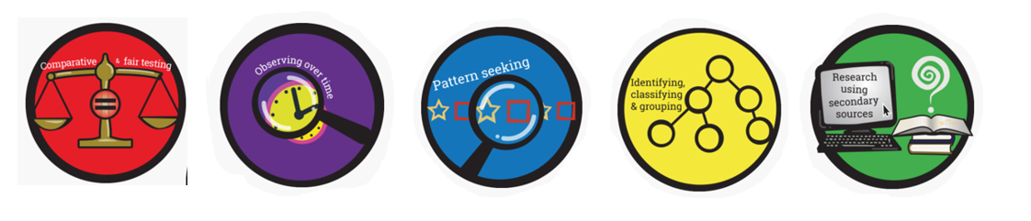 | Key words:
  Magnetic material | A material that gets pulled toward (attracted by) a magnet.
  Non-magnetic material | A material that is not attracted to a magnet.
  Push | A force on something to move it away from yourself.
  Pull | A force on something to move it towards yourself.
  Magnetic force | A push or pull force that a magnet has on certain materials.
  Attract | A pull to move something closer - for example, a magnet and a paper clip.
  Repel | A push to force something to move away or apart.
  Contact force | Forces which can act on an object through direct physical contact with it (touching it).
  North pole | The end of a magnet, this will pull towards a South pole of another magnet.
  South pole | The end of a magnet, this will pull towards a North pole of another magnet.
Key people
Andre Marie Ampere – French physicist and mathematician who worked on electro-magnetism.
The Wright Brothers – American inventors who built and flew the first planes.
Exciting books/ web links:
Act Normal, Don’t Tell Anyone about the Rhinoceros Magnet – Christian Darkin.

https://www.bbc.co.uk/bitesize/topics/znmmn39

https://learning-resources.sciencemuseum.org.uk/resources/magnetic-maze/

Parents as partners:
Create ‘magnet maze’ out of card, then use a magnet held underneath to guide a steel ball around the maze (see weblinks).
Could your child use magnets to create ‘magic’ floating paperclips (see weblinks)?
Make a compass then use this to navigate your way round the garden (or for a treasure hunt!).

