 | DT: Textiles: Cushions
 | Year Group: 4 | Subject Focus: DT | Term: Summer 1
Key Knowledge:  - Methods to attach one piece of material to another.  - How to sew on a button.  - Using a pattern piece to measure and cut fabric.  - Pattern pieces should usually be decorated before joining.  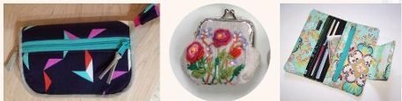  Running Stitch  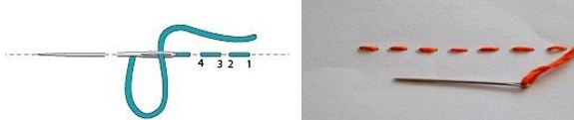  Useful Websites  - BBC Bitesize - Textiles and Sewing - Interactive learning about textiles and sewing techniques.  - National Gallery - Art and Textile Design - Explore different textile designs from famous artworks.  - Education Scotland - Textiles - Resources for teaching textiles in an engaging way. |  | Design and Technology: Skills and Enquiry  - Generate ideas for products after thinking about who will use them and what they will be used for?  - Select appropriate tools and techniques for making their product  - Reflect on the progress of their work as they design and make, identifying ways they could improve their products  - Recognise that the quality of a product depends on how well it is made and how well it meets its intended purpose  - How materials can be combined and mixed to create more useful properties?  Design – Make – Evaluate  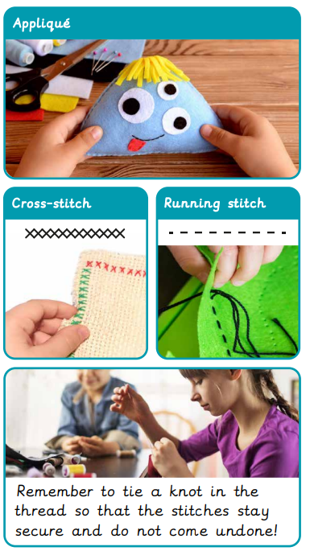 | Key words:  Curriculum Links  Science - opportunities to consider different materials  Art - opportunities to create observational drawings
  Applique | Where small pieces of cloth are sewn or glued on to make a deisgn
  Cross-stitch | A two-stitch style of sewing which forms a cross pattern.
  Cushion | A soft, stuffed shape made of fabric.
  Embellish | To add decorvative details to something.
  Fabric | A natural or man-made woven or knitted material.
  Patch | A piece of fabric sewn onto a larger piece.
  Running stitch | A basic sewing stitch made in a straight line with space between stitches.
  Seam | The line where two pieces of fabric are sewn together
  Template | A tool used to make copies of a shape or to cut a material accurately.
  Stuffing | Soft material used to fill cushions and stuffed toys.
?

