Year 3 Newsletter (Summer 1)

Our learning journey
Geography  Our new topic focus is all about Leeds. We will explore this by developing our map skills by locating Leeds on a map and key geographical features using a 4-point grid reference. We will also learn geographical facts about Leeds.  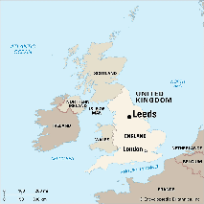 | Science  Year 3 will finalise their learning about forces and magnets. We will explore how different forces work, including pushes and pulls, and investigate how magnets attract and repel. We will then move on to our topic of plants with a focus of their parts and their functions.  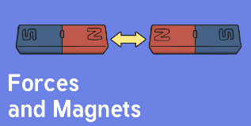 | Maths  This half term in Maths, we will complete our work on fractions, understanding reasoning with fraction amounts.  We will also dive into money and explore how to add and subtract amounts. We will reach the end of the term by focusing on time.  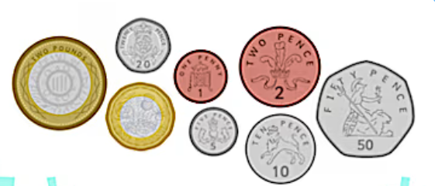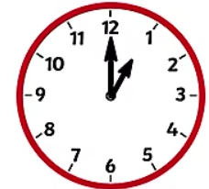 | English and Reading  This half term, we will be starting our new class reading book ‘an Alien in the Jam Factory’. In English we will begin our learning by writing a persuasive leaflet about visiting Leeds linking to our geography learning. We will then explore a range of poems to then write and perform a rhythmic poem.  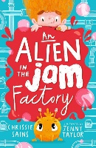

Other:  - PE days are on a Monday and a Tuesday. If your child wears earrings, please make sure that they are taken out or covered before school on these days.  Dates: | Class routines:  - The children are expected to read at home every night. Reading records and books should be brought to school every day so that a member of staff can read with them in school. These reading books will be changed on a Friday if the reading record has been signed.  - Each Friday, the children will complete a spelling quiz. Spellings will be sent home of a Friday and should be practised at home.  - Pupils should continue to log onto TTRockstars to improve their times tables knowledge. This can be done through ‘Jamming’ focusing on our 2,3,4,5,8 and 10 times tables.

Finally, please remember to log onto the class page on the school website to keep up to date with our latest news: https://www.crossgatesprimary.co.uk/class-pages/ or by accessing Reach More Parents.
Miss Croft

