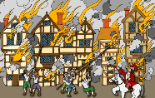 | The Great Fire of London |  |  | 
 | Year Group: 2 | Subject Focus: History | Term: Summer 1
Key facts  - The Great Fire was caused by several factors (wind, summer weather, hygiene, width of streets, close proximity of buildings.)  - After the fire there were many changes made in the rebuilding of London to prevent another fire.  - The diaries of Samuel Pepys have played a major part in our understanding of the events of the Great Fire of London.  - The Great Fire of London lasted just under 5 days and one-third of the city was destroyed. 100,000 people were made homeless.  - The monument in London is one way we commemorate the event to this day.  - The Great Fire helped to end the Plague in London by killing the rats and fleas which carried the disease.  - As young historians we have to be aware of the problems with sources of information relating to any historical event. |  | Parents as partners:  - Talk about why fire is dangerous and what you do at home to keep safe from fire?  - What are houses made out of today? Can you draw or make a model of your house and label the materials that it is made out of, or write a list?  - What is your favourite landmark in London? We will be looking at these in our Art lessons.  - Look at pictures of different kings and queens of England.  - Draw a picture of some of the houses on your street – what are the similarities and differences?  Exciting books/ web links:  http://www.fireoflondon.org.uk/game  https://www.bbc.co.uk/newsround/37222884  https://www.bbc.co.uk/bitesize/topics/z7d7gwx/articles/zhgxcqt  http://www.fireoflondon.org.uk/  www.youtube.com/watch?v=weEveQ4nz4g  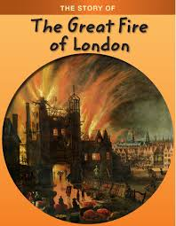  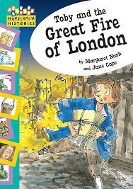 | Key words:
  century | period of 100 years
  chronology | the order of events in time
  disaster | a sudden accident or event that causes great damage
  eye witness | a person who has seen something happen and can give a first-hand description of it
  fire hook | a tool used by firefighters to pull down buildings to stop fire spreading
  monarchy | a system where a country is ruled by a king or queen
  overcrowded | a space which is filled beyond what is comfortable, safe or desirable
  plague | a disease that affected humans after being bitten by a rodent flea carrying the disease
  settlement | a place where people live and sometimes work
  sources | something from which we can find out information about an event
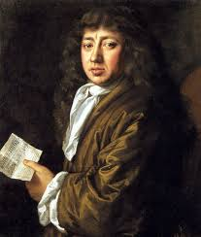

Key people/ places
Samuel Pepys lived in London and saw the fire as it happened. He wrote about it in his diary.
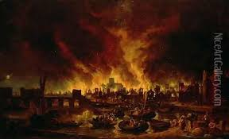

London - the capital city of England.

Themes
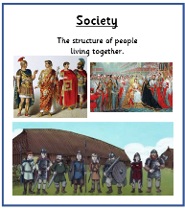
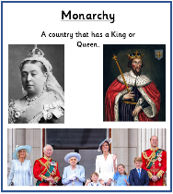
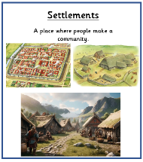
Timeline
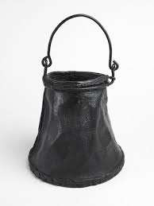
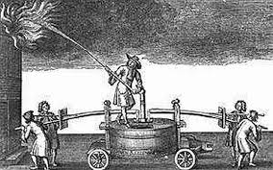
47AD 1666 2020
Romans Great Modern day
founded Fire of London – affected by
Londinium London Covid

1605 1716
Gunpowder (Approximately)
Plot rebuilding of
London completed

