 | Art: Painting and Mixed Media – London Skyline
 | Year Group: 2 | Subject Focus: Art | Term: Summer 1
Skills:  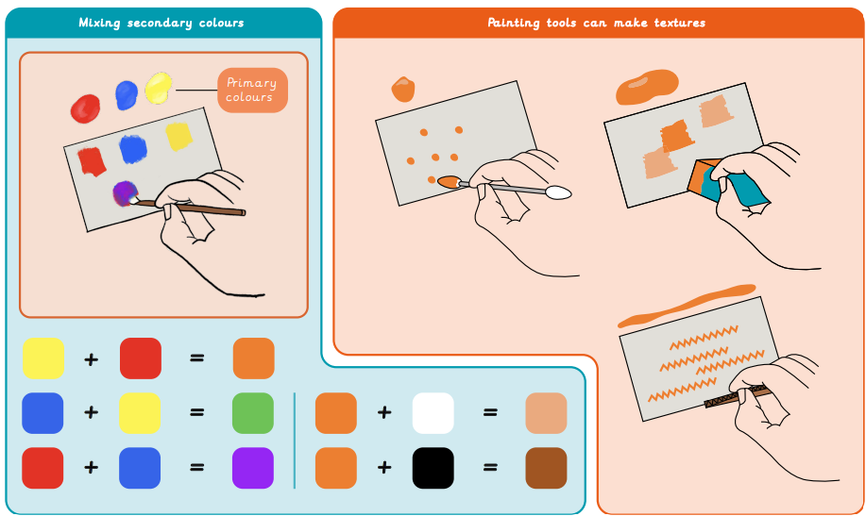  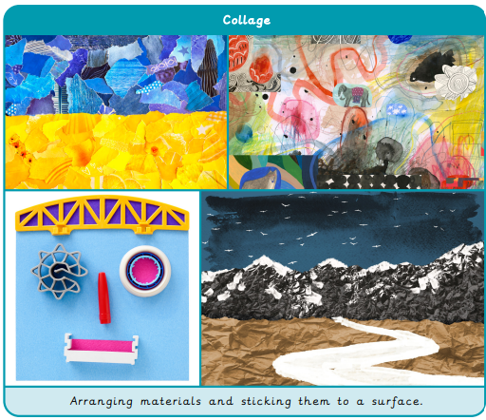 |  | Famous Artwork:  Megan Coyle  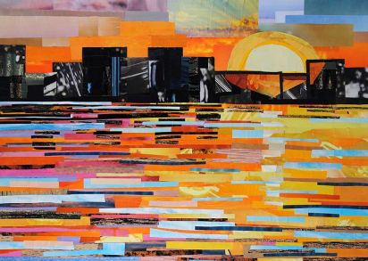  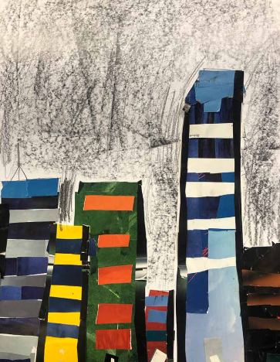  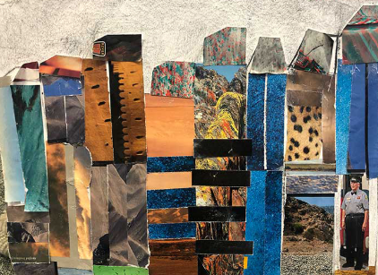 | Key words:  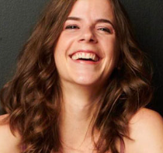  About the artists:  Megan Coyle  - Born in Virginia, America  - She wanted to be a writer.  - Influenced by Vincent Van Gogh  - She is a collage artist.  - She now lives in New York.
  collage | A piece of art made by sticking different materials on to a backing.
  colour | What we see when light shines on an object and reflects back into our eyes.
  creation | Using imagination and skills to make something.
  detail | Small specific parts of artwork.
  mixing | Combining different colours to create new shades.
  overlap | Placing a material on top of another one.
  primary | Red, yellow and blue are colours that other colour can be made from.
  secondary | Created by mixing 2 primary colours together.
  surface | The visible area of artwork.
  texture | The surface of a piece of art.
Born in V

