
Year 2 Summer 1 Newsletter
Welcome back!
Year 2 continue to enjoy our learning, as well as developing our skills and knowledge.
In Maths, we will be learning how to measure.
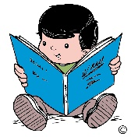
In English we are using the book ‘Toby and the Great Fire of London’ to write a newspaper report. We will also be writing a description of a setting.
In Science our unit of study is ‘Plants’. We will be looking at the different parts of a plant and how they grow.
In Music we will be looking at different instruments and the sequence of sound. PSHE sees us learning about keeping ourselves safe. In RE we will be learning about how symbols are used to welcome new life.
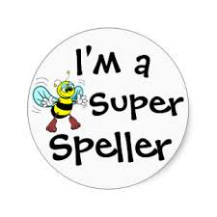
In Art we will be painting a London skyline, while Computing sees us making music and in French we are going to be learning nursery rhymes.

We will continue to work with our coaches in PE. We would like to remind you again that our PE days are Tuesday and Friday and your child needs to wear their school PE kit on those days. Please do not send your child in branded sportswear or clothing with writing on. We would also request that, in line with school policy, any earrings are removed on these days.
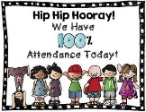
The children will continue to bring home spellings each week, usually on a Friday, that they will need to learn for a test the following Friday. We always appreciate your support with helping your child learn their spellings.
Your child’s regular attendance, as always, is essential. Children find it very difficult to keep up with their work and very quickly fall behind, if their attendance is not consistent. Obviously genuine illness is a different matter.
If you would like to know anything regarding your child in Year 2, please do not hesitate to contact us. We would like to thank you for your continued support.
Mrs. Austin and the Year 2 Team

