 | The Maya |  |  | 
 | Year Group: 4 | Subject Focus: History | Term: Summer 1
Key facts  - Maya cities had similar layouts to each other. They would have a palace for the ruler, a plaza for the market places and temples in the form of pyramids.  - Maya cities were often found near trade routes and good farmland.  - Mayas were polytheists – believing in many nature Gods or deities.  - Priests were considered the most important people in the Maya culture: warriors, craftsmen and traders were next in the hierarchy. Farmers, workers and slaves were at the bottom of the hierarchy.  - Maya merchants traded many goods: salt, cotton, honey and jade.  - The Maya calendar (Tzolkin) consisted of 260 days and 13 months.  - The demise of the Mayan civilisation came about because of a mixture of deforestation, land erosion and drought. |  | 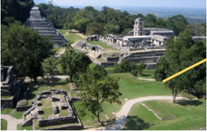  We will look at:  - how the Maya civilisation has had an impact on modern society.  - times of little change and times of great change.  - the ideas, beliefs and attitudes of all groups of people in Maya civilisation.  Key Themes  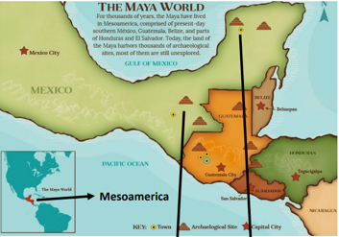  In our study of the Maya, we will continually connect our learning to some of the overarching history themes of society and monarchy. | Key words:
  architecture | The art of planning, designing and constructing buildings.
  chronology | The order of events in time.
  civilisation | A human society with its own organisation and culture.
  continent | A large area of land that covers many countries.
  culture | Activities such as arts and philosophy – important for the development of civilisation.
  demise | Something or someone who is at their end or death.
  drought | A long period with no rain.
  economy | The wealth that a society or country gets from business or industry.
  Mayan | Relating to the characteristics of the Maya people and their language.
  Mesoamerica | Central America – Mexico, Guatemala, El Salvador, Belize.
Did you know?
- South America is a continent.
- The climate in South America is different to the UK.
- Other civilisations include the Egyptians and the Greeks.
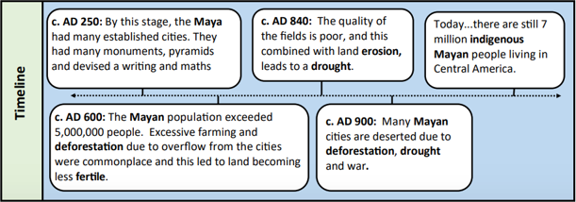
 |  | Exciting books/ web links:  https://www.dkfindout.com/uk/history/mayans/  https://www.ducksters.com/history/maya/daily_life.php  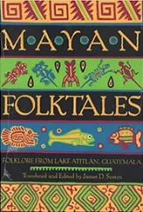  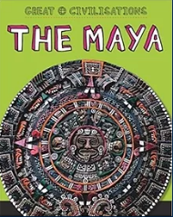  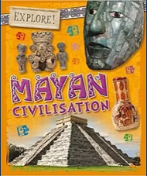 | Parents as partners:  You could do some research online with your child.  Find some interesting facts about the Maya.  Read a story that is connected to the Maya civilisation.  

