 | Weather and Seasons |  |  | 
 | Year Group: 1 | Subject Focus: Geography | Term: Summer 1
Key facts  - The weather changes regularly and tends to be different during different seasons and across different countries.  - Weather symbols are used as a ‘quick’ and ‘easy’ way to show the current weather happening in certain places.  - There are differences in the weather, length of day light and plant life during different seasons.  - In the UK, there are four different seasons. Each season has a different type of weather.  - Winter is cold, wet and windy. It snows in some areas and gets dark early.  - Spring brings warmer weather. Flowers start to grow and baby lambs are born.  - In summer, the weather becomes hotter; there is less rain, but there may be more thunderstorms.  - The weather starts to get colder in autumn. Leaves change colour and fall off the trees. |  | 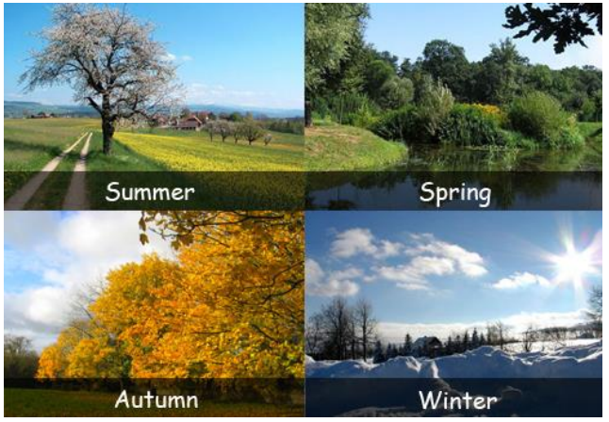  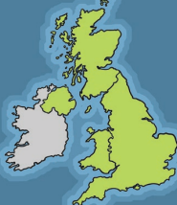  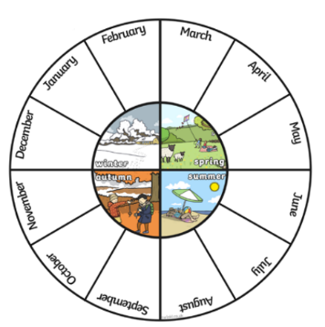 | Key words:
  Seasons | A time of the year with a particular type of weather.
  Spring | The season after winter and before summer.
  Autumn | The season after summer and before winter.
  Winter | The season after autumn and before spring.
  Summer | The season after spring and before autumn.
  Temperature | How hot or cold it is.
  Forecast | Explaining what the weather will be like.
  Symbols | Pictures or signs that help us understand something.
  Observations | What you notice when you look carefully at something.
  Thermometer | An instrument used to measure temperature.
Weather
These are different types of weather. What is your favourite type of weather?

Can you keep a record of the weather for a whole week?
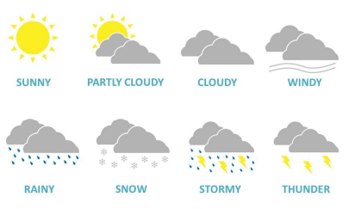

 |  | 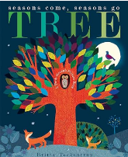  Exciting books/ web links:  Tree: Seasons come, seasons go  https://www.bbc.co.uk/bitesize/topics/zwv2wnb/articles/zcx3gk7  https://www.bbc.co.uk/bitesize/topics/zwv2wnb/articles/z7dkhbk | Parents as partners:  - Create a weather chart and record the daily weather patterns and temperature.  - Explore your local area and see what signs of spring you can see.  - Can you draw a picture of each season?

