 | Seasonal Changes |  |  | 
 | Year Group: 1 | Subject Focus: Science | Term: Summer 1
Key Facts  - There are four seasons in the year and there are three months for each season.  - During the seasons, the weather changes from hot to cold!  - Winter is cold and wet. The nights get longer and the days become shorter.  - Summer is where the nights become shorter and it is sunny more often.  - In Spring, new life begins. Trees grow their leaves back and flowers begin to bloom.  - In Autumn, the leaves fall from the trees and change colour.  - Throughout the year, there are different weather patterns and the day varies according to the season it is.  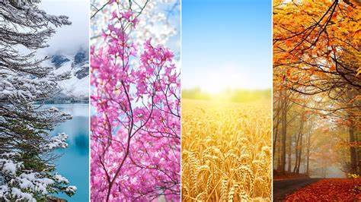 |  | 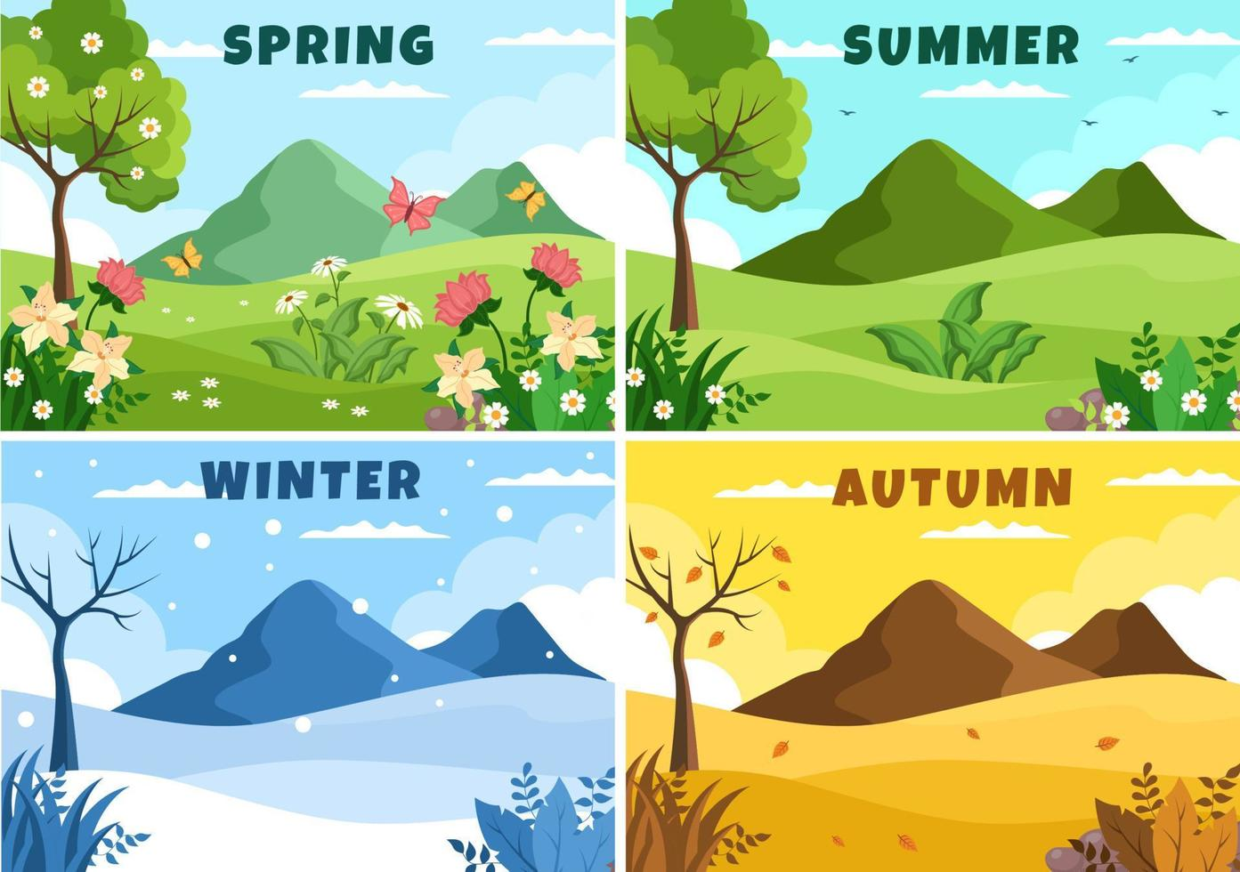  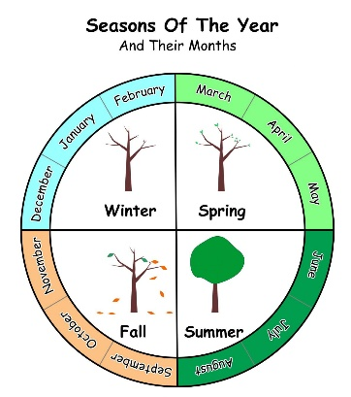  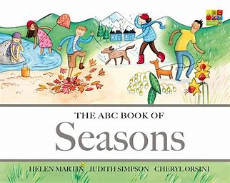  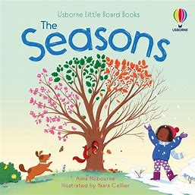  Exciting books and websites –  Seasons Song  What are the seasons? - BBC Bitesize | Key words:  .  Parents as partners:  - Visit local parks or go on walks. What do you notice about the trees? Can you spot any leaves on the ground? Are there any flowers about?  - Can you collect different flowers and leaves from outside and create a picture with them?  - Take a picture during each season and then compare them. What is the same? What is different?
  Seasons | A time of the year with a particular type of weather.
  Spring | The season after Winter and before Summer.
  Summer | The season after Spring and before Autumn.
  Autumn | The season after Summer and before Winter.
  Winter | The season after Autumn and before Spring.
  Change | Make something different.
  Observation | When you carefully notice something.
  Temperature | How hot or cold something is.
  Pattern | Something that is repeated.
  Forecast | Explaining what the weather is like.

