 | Art: Sculpture – Clay houses
 | Year Group: 1 | Subject Focus: Art | Term: Summer 1
Skills:  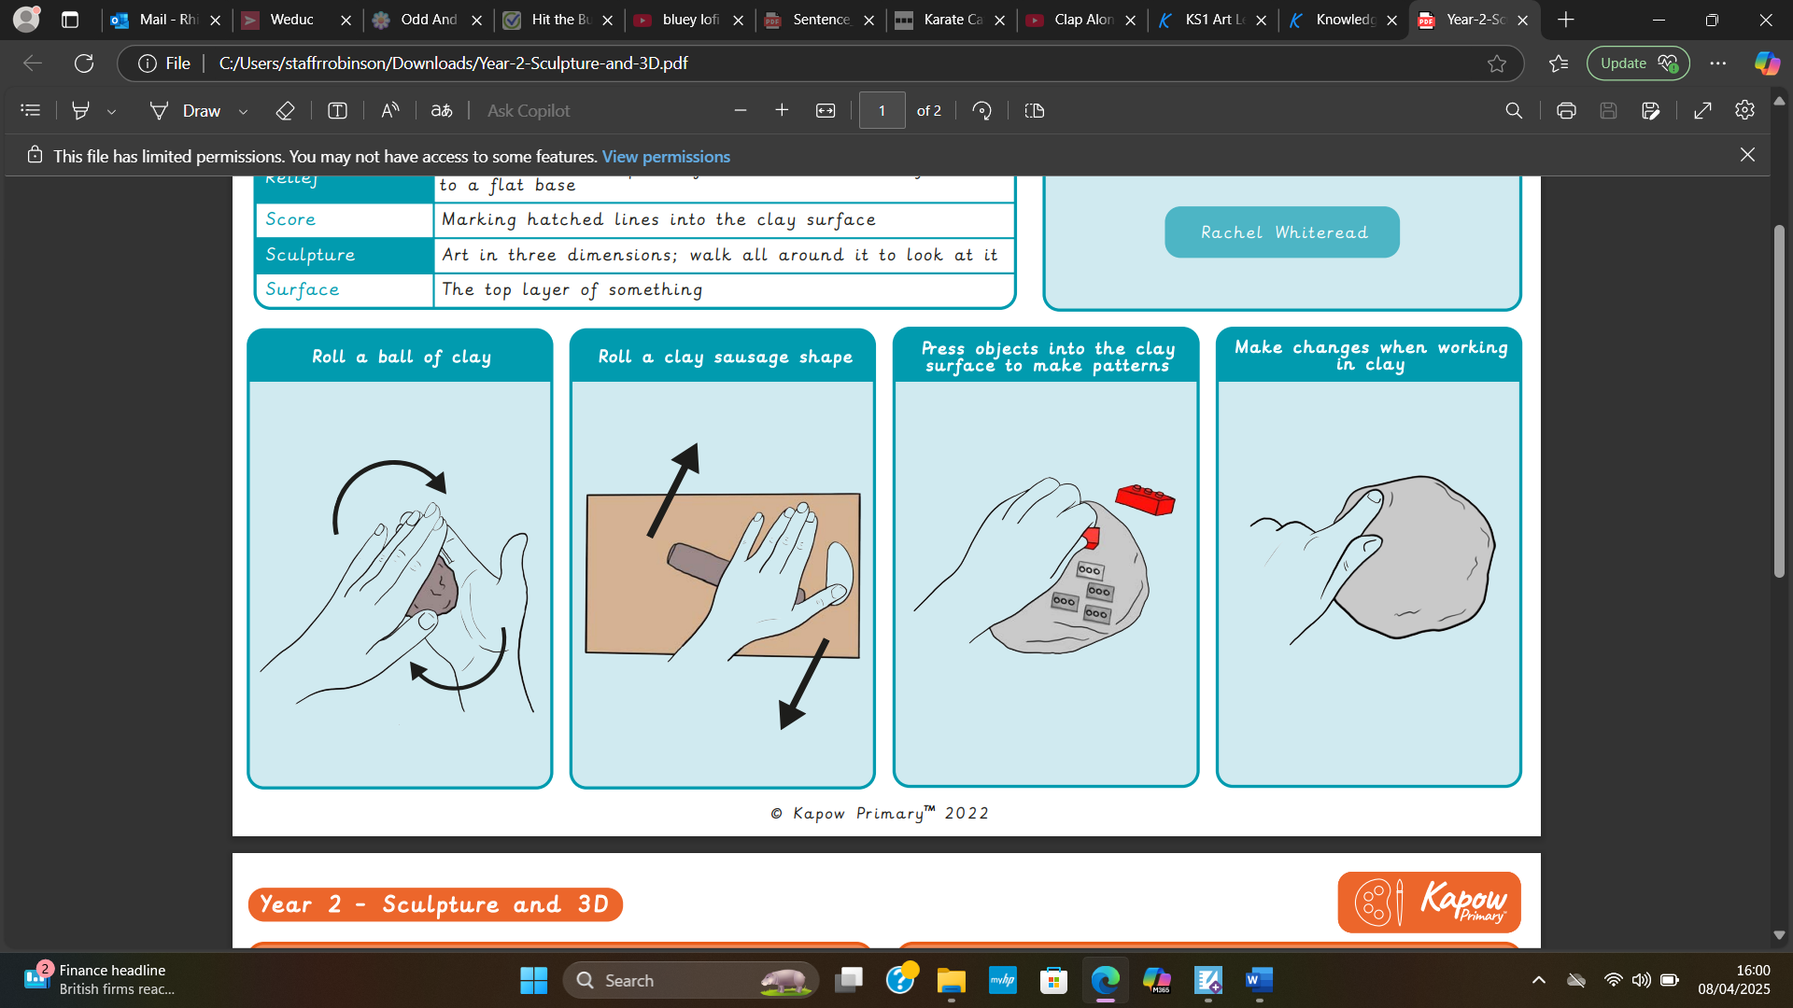 |  | Famous Artwork:  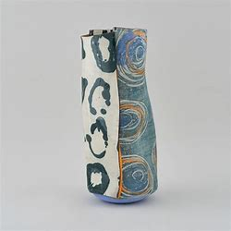  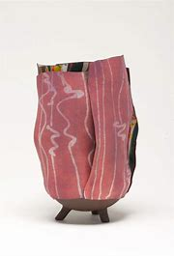  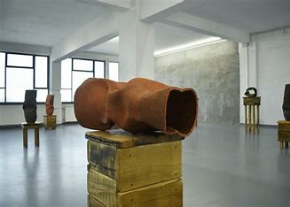 | Key words:  About the artist:  - Ranti Bam.  Ranti is a British- Nigerian artist from London who makes colourful and sculptural ceramics with clay techniques
  Smooth | Having an even surface.
  Flatten | Making something flat.
  Pinch Pot | A simple pot formed by pushing your thumb into a ball of clay.
  Detail | Adding texture or features to the clay.
  Score | Marking hatched lines onto the surface of the clay.
  Glaze | Putting a glossy coating on the clay.
  Slip join | A runny mixture of clay and water mixed together which creates a glue.
  Sculpt | Create something by carving or casting.
  Sculpture | Art in three dimensions, you can walk all around to look at it.
  Sculptor | An artist who makes sculptors.

