Welcome back Year One! I hope that you are all feeling refreshed ready for this very short half term. Can you believe we only have two half terms left of Year One? Below is everything we will get up to this half term, we have lots of exciting learning happening. As always, thank you for your continued support with your child.
Maths | English | Geography | DT
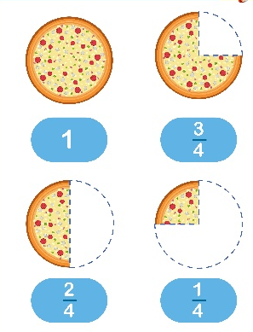  In Maths, we will be looking at fractions. We will be finding halves and quarters of a quantity. We will also be furthering our knowledge of multiplication and division. | This half term, our writing will be based on fairy tales. We will start by learning the story of The Three Little Pigs. We will then retell the story, using lots of drama to help us remember it. We will continue using precursive handwriting, ensuring we are writing to the best standard we can every lesson! | We will be looking at weather patterns and seasonal changes. We will learn which month falls with the different seasons and create our own weather report using symbols.  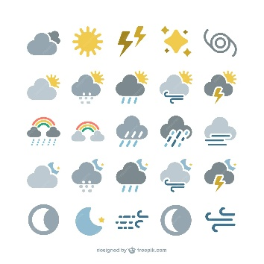 | In our DT lessons, we will be learning about how to make a healthy smoothie. We will learn how to cut fruit and vegetables properly and we will become super taste testers to try and get the perfect smoothie flavour!  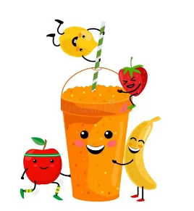

Important Information –  - Year One will have PE on a Wednesday and Thursday afternoon. Please ensure they have their PE kit with them on these days.  - Please continue to work with your child practising their phonics. The screening test is in June and any extra work will be greatly beneficial to your child. Any questions about this or if you would like some practise phonics materials, please come talk to me. | Things to know –  - Each Friday, the children will complete a spelling test. Spellings will be sent home on a Friday and should be practised at home.  - Reading records and books should be brought in to school on a Thursday. Please ensure you are reading at home with them too.  - New library and reading books will be sent home on a Friday for the children to read over the weekend.

Keep up to date with your child’s learning by going on to the school website and see what they have been doing. Year 1 | Cross Gates Primary School .Any questions about your child or their learning, please feel free to come to me to arrange a time to meet.

