 | DT: Cooking and Nutrition - Smoothies
 | Year Group: 1 | Subject Focus: DT | Term: Summer 1
Key facts:  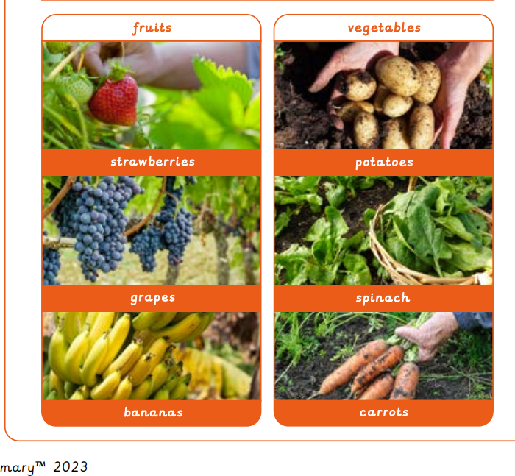  - If there are seeds in food, then it is a fruit. If there are no seeds, then it is a vegetable. Fruit can grow on trees and plants.  - Vegetables can grow either under or above the ground.  - Vegetables are the edible part of any plant.  We Are Learning To:  - Design, create and evaluate smoothies.  - Chop fruit correctly using a knife.  - Blend our chosen fruits together using a blender.  - Be safe when in the kitchen. |  | Technical Knowledge:  Skills to be used in this topic -  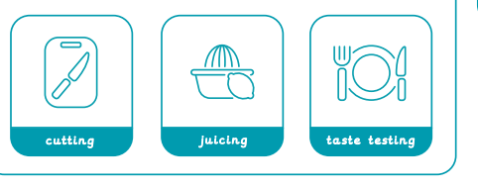  Cutting –  - When cutting, make sure you hold the knife properly and have your other hand on the end of the object you’re cutting.  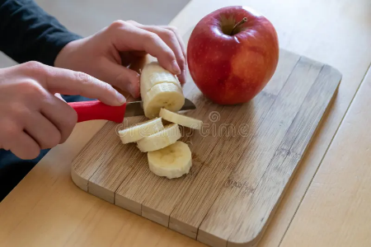  Juicing –  - When juicing, make sure that the lid is properly on and fingers are no where near the blades! | Key words:  .  Real life:  - Smoothies are a great way to have lots of fruit and vegetables all in one go!  - Smoothies have been around for hundreds of years and are popular in sunny countries.  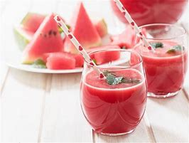
  Evaluate | To say what went well and what we would change for next time.
  Blend | When you mix two things together.
  Ingredients | The foods needed to make a recipe.
  Juice | To get the juice out of a fruit or vegetable.
  Design | A plan of how you want something to look or turn out to be.
  Smoothie | A thick, smooth drink made of fresh fruit.
  Seed | New plants grow from it.
  Flavour | The taste of food or drink.
  Recipe | A set of instructions telling you how to make a certain dish.
  Healthy | Something that will make your bones stronger and keep you fit.

