 | Art: Sculpture and 3D
 | Year Group: 5 | Subject Focus: Art | Term: Spring 2
Key facts:  - Installation art is three-dimensional art that aims to transform a particular place.  - It is often large in scale.  - Location is very important.  - It is often made using everyday objects in new ways.  - It can be interactive.  Useful links:  BBC Art Ninja: the construction of an installation  https://video.link/w/5Izzd  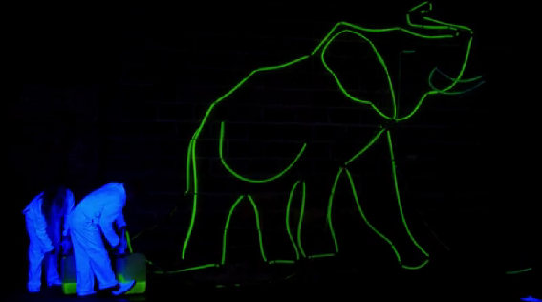  Did you know?  Sculpture art can be made from anything!  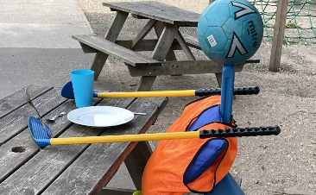  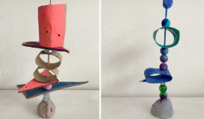 |  | Famous Artwork:  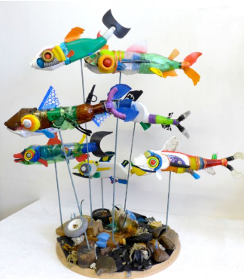  Michelle Reader: A Bellyful of Plastic  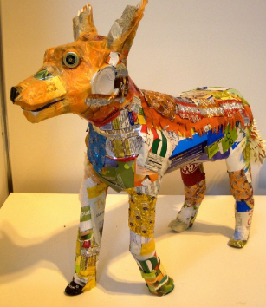  Michelle Reader: Art from Found Things | Key words:  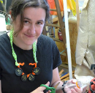  About the artists:  Michelle Reader  Michelle has been making art from waste materials since 1997, and she also has a background in design for performance.  She makes recycled sculpture and art from unusual materials. In addition to this, she works with theatre companies and schools, running art workshops for children.  Parents as partners:  - Have a go at creating a sculpture using equipment/things you have at home!  - Research some local sculpture artists and create a fact-file about them.  - Take a local walk and see if you can spot any sculptures or 3D installation art!
  three-dimensional | an object with three-dimensions: height, width and depth
  installation | putting/constructing art in a certain space
  interactive art | artwork that relies on the participation of someone
  performance art | art that is created through actions performance by the artist or other participants
  atmosphere | the mood of an artwork (mysterious, joyous)
  concept | the idea behind an artwork
  scale | the making of art in three-dimension
  location | the place where artwork is displayed
  viewer | the people who look at, or visit your installation/artwork
  sculpture | how the artwork is arranged or organised

