Scandinavia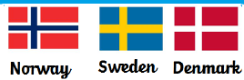 | Vikings |  |  | 
 | Year Group: 5 | Subject Focus: History | Term: Spring 2
Key facts  - The Vikings (also known as Norsemen) came from three countries of Scandinavia: Denmark, Sweden and Norway.  - The name ‘Viking’ means ‘a pirate raid’. People who went off raiding in ships were said to be ‘going Viking’.  - Vikings sailed the seas, on longboats, raiding and taking over land.  - The Viking raids started out as short trips to steal treasure and take slaves.  - In time, the Vikings made their home in Britain and took it for themselves.  - The Saxon King, King Alfred of Wessex, fought them in a great battle, but he could not stop them at first so had to let them have part of the country. This area was known as Danelaw.  - Not all the Vikings were bloodthirsty warriors. Some were farmers, who kept animals and grew crops.  - Some were skilful craft workers, who made beautiful  metal work and wooden carvings.  - Everyone lived together in a large home called a longhouse.  - The Vikings also brought with them their way of life and beliefs. |  | Timeline  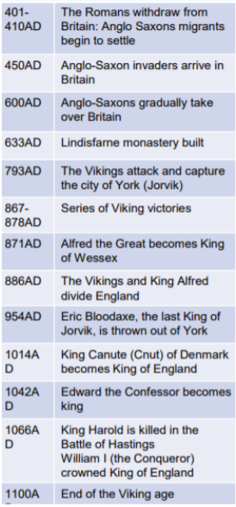  What we call the Viking Age, and their relationship with England, lasted from approximately 800 to 1150 AD  In 866 AD, the Vikings captured modern York (Viking name: Jorvik) and made it their capital. | Key words:
  danegeld | money paid to Vikings to stop them from raiding
  Danelaw | an area in Britain that the Danish Vikings ruled over.
  knarr | a Viking ship used for long voyages and trading; it had lots of storage space
  longship | a Viking ship used for fighting and carrying out raids
  Pagan | a person who believes in many gods
  plunder | take loot during a raid, often causing damage at the same time
  society | the structure of people living together
  Scandinavia | the countries of Norway, Sweden and Denmark, this is the area Vikings came from
  Valhalla | the place Vikings believed they would go to after death if they died fighting bravely in battle
  wergild | compensation paid by someone who has committed a crime to an injured person of family
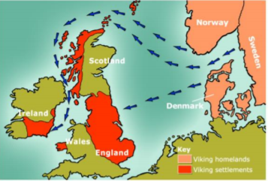
Did you know?
England had four Viking kings between 1013 and 1042. The greatest of these was King Cnut, who was King of Denmark as well as of England.

Many towns and cities in Britain today were founded by the Vikings; places that end in –by (Whitby), -thorpe (Scunthorpe) or –kirk are most certainly Viking towns.
 |  | 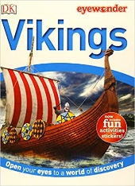  Exciting books/ web links:  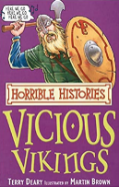  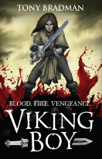  http://www.primaryhomeworkhelp.co.uk/vikings.html  https://www.bbc.co.uk/bitesize/topics/ztyr9j6  https://www.bbc.co.uk/teach/ks2-history/zfbwhbk | Parents as partners:  - Encourage your child to create some amazing fact cards about the Vikings.  - Together, make a Viking longboat or longhouse using recycled materials.  - Create a word search or crossword about the Vikings.  - Visit some of the websites listed on this page and talk about what you discover.  - Arrange a visit to the Jorvik Viking centre.

