Year 6 Newsletter (Spring 2)

Welcome back to Blackman Class in year 6! As we continue on our journey through year 6, we look forward to lots of learning and exciting projects this half term.
Our learning journey
This half term we will be again focusing on geography in our topic lessons. We will investigate trade links and why Fairtrade is so important to the global economy. We will also be linking our DT lessons to this topic by using Fairtrade products in our food technology lessons. Please see the knowledge organiser to find out more.   | In Science, we are continuing to work on  living things and their habitats. We will learn all about how to use and create classification keys. During these lessons, we will think about how the different plants and animals can be categorised.  We will then focus on Evolution and Inheritance.  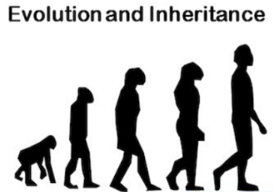 | In our Maths lessons we will continue to work on our arithmetic skills in preparation for our upcoming tests. This will include revising fractions, decimals and percentages.  We will also be focusing on, perimeter, area, volume, angles and algebra this half term.  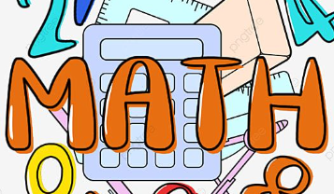 | In English we will focus on formal writing by creating a nonchronological report. We will then write our own poetry based on The Jabberwocky by Lewis Carroll.  In reading we will focus on the novel: Skellig.  We will also be working on our spelling, punctuation and grammar as well as developing our comprehension skills throughout the half term.  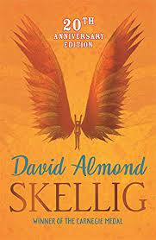

Diary Dates:  - Reminder that our residential to Willersley Castle is taking place on Wed 4th March – Fri 6th March. All payment is now due.  - PE will continue to be on a Monday and Thursday. Children need to wear their PE kits to school and bring a water bottle.  - The year 6 SAT tests will take place from Mon 11th May – Thu 14th May. More details to follow.  - High School offer day Mon 2nd March. If you applied online, your offer will be sent by email. | Class routines:  - The children are expected to read at home every night and have their reading record signed by an adult. This is the single most useful thing that parents can do to support their children’s learning.  - Each Friday, the children will complete a spelling and mental maths quiz. The spellings and maths focus will be sent home on a Friday, ready to learn for the following Friday. Please work on these frequently at home.  - Please see the class website page to help prepare the children for our upcoming year 6 tests. There are useful links for the children to revise at home.  - Pupils should also continue to log onto TTRockstars to improve their times tables knowledge.
Finally, please remember to log onto the class page on the school website to keep up to date with our latest news.
Miss Wilson, Mrs Pavey & Mrs Lister

