 | Living things and their habitats
 | Year Group: 6 | Subject Focus: Science | Term: Spring 1&2
Key facts  - Animals can be grouped into carnivores, herbivores and omnivores. They can also be grouped into vertebrates and invertebrates.  - Organisms can be classified and we can use a classification key to identify them.  - The categories for classifying vertebrates are: Reptiles, Fish, Amphibians, Birds and Mammals.  - Living things depend on each other in order to survive.  - Environments and habitats are changing, which impacts how well animals thrive.  - Food chains demonstrate the direction in which energy travels.  - Organisms have adapted and evolved over time.  Did you know?  - A classification key is a tool that is used to group living things to help us identify them using recognisable characteristics. In 1735, Swedish Scientist Carl Linnaeus first published a system for classifying all living things. An adapted version of this system is still used today: The Linnaeus System.  - Microorganisms Are very tiny living things. They are not visible to the naked eye so a microscope is needed to see them. Microorganisms are found all around us, they can live in our bodies, in water, in the air and on the objects around us.  - Examples of microorganisms include dust mites, bacteria and fungi, such as mould. |  | 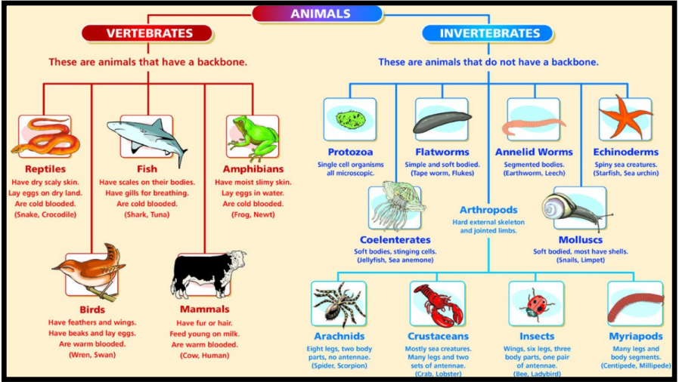  Exciting books / web links:  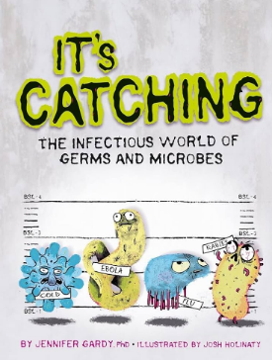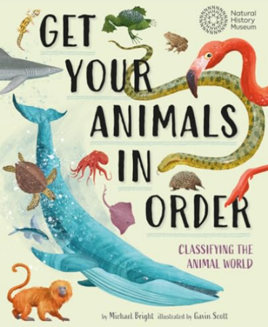  https://www.bbc.co.uk/bitesize/articles/zyq9r2p#z7rhhcw  https://www.bbc.co.uk/bitesize/articles/zsgtrwx  https://www.stem.org.uk/resources/community/collection/11373/micro-organisms | Key words:  Parents as partners:  - Glitter Germ Investigation https://www.livinglifeandlearning.com/glitter-germ-experiment.html  - Experiments to do at home  https://learning-center.homesciencetools.com/article/bacteria-experiment-guide/  - Create an animal fact file showing how they can be classified.  - Create a PowerPoint all about classifying animals and/or microorganisms.
  Appearance | The way an organism looks in order to be classified.
  Bacteria | Tiny living thing made up of just one cell. They are everywhere! They live in soil, on your skin and even in your gut.
  Characteristic | A special feature or quality that helps us to describe a living thing.
  Classification | The arrangement of organisms into orderly groups based on their similarities and presumed evolutionary relationships.
  Disease | Something that harms how an organism works or functions.
  Exoskeleton | A hard covering that protects the bodies of invertebrates.
  Infection | Is when harmful microorganisms (such as germs) get inside the body and start to multiply.
  Microorganism | An organism which is microscopic, making it too small to be seen by the human eye.
  Organism | An individual animal, plant or single celled life form.
  Virus | Miniscule germs that are much smaller than bacteria. Unlike most living things, viruses cannot survive on their own and need to invade a host cell to grow and multiply.

