 | DT: Cooking and Nutrition (Come dine with me)
 | Year Group: 6 | Subject Focus: DT | Term: Spring 2
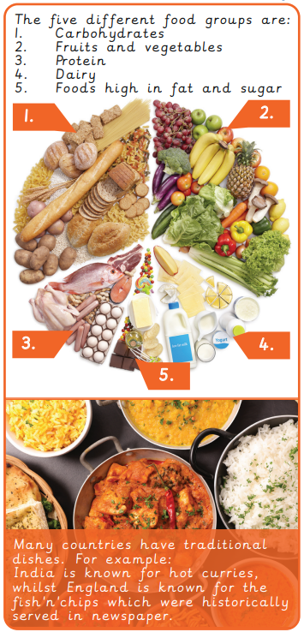  Key facts: |  | Technical knowledge:  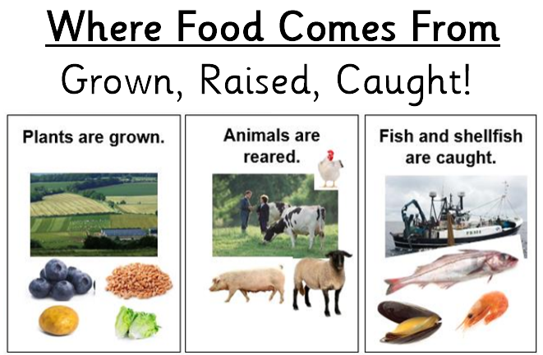  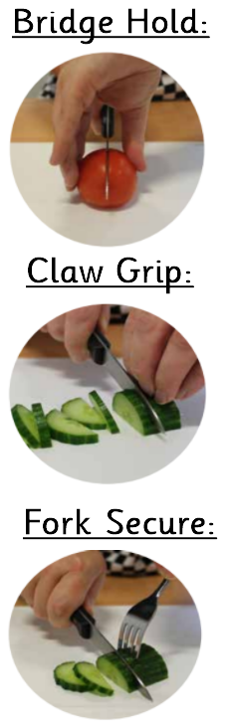  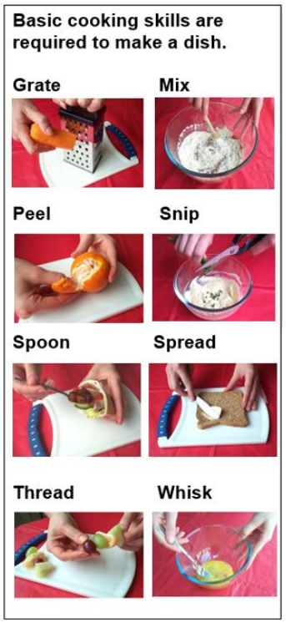 | Key words:  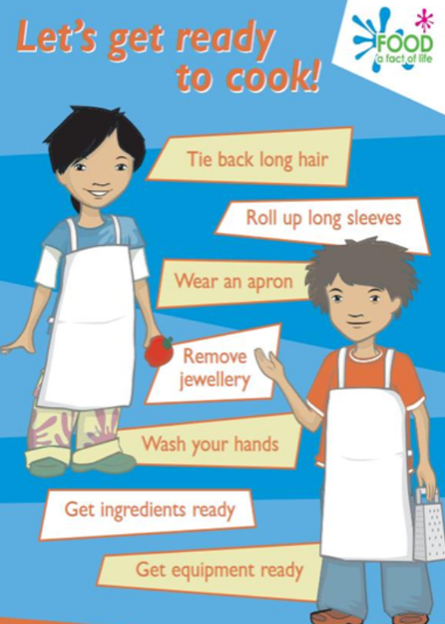
  Accompaniment | Something which goes well with other foods and beverages.
  Cross Contamination | How bacteria can spread when liquid from raw meats or germs from unclean objects touch ready-to-eat foods.
  Flavour | How food testes (e.g. sour, sweet, bitter, salty).
  Ingredients | Items that make up a mixture / food that make a recipe.
  Method | Following a list of instructions or recipe. The process involved in making something.
  Preparation | What you need to do before you make something.
  Processed | When foods are passed through multiple processes in a factory. This is to change or preserve it so that it lasts for longer.
  Reared | To breed or raise livestock (e.g. cows).
  Recipe | A set of instructions for making or preparing a food item or dish.
  Target Audience | A particular group or person who a product is aimed at.

